CSS ISLAMIC STUDIES · T8KB
بِسۡمِ ٱللَّهِ ٱلرَّحۡمَٰنِ ٱلرَّحِيمِ
Topic VIII — Public Administration and Governance in Islam
The Knowledge Base · Public administration, Quranic guidance on good governance, Shura and legislation, the Khilafat-e-Rashidah, the letters of Hazrat Umar and Hazrat Ali, civil servants, and accountability and Hisbah
Ten chapters built from the eight lines of syllabus Head VI and from the nine questions set on this topic between 2016 and 2026, with the contemporary debates, the examiner's record, five likely questions, a numbered one-liner bank and section-by-section revision notes. Every point carries its evidence — the Quran first, then the Hadith, then the Rightly-Guided Caliphs, the jurists, the law and the data — inside the point itself.
Edition of September 2026 · covers the papers of 2015–2026 · written for CSS 2027 and after
Contents
HOW TO BUILD THE CONTENTS
The Contents below is left empty on purpose. In Microsoft Word, right-click anywhere on the grey line below and choose Update Field → Update entire table → OK. The full table of contents with page numbers will appear.
On a Mac: right-click (or Control-click) the line → Update Field. If you edit the notes later, repeat this step to refresh the page numbers. You can also press Ctrl + A then F9 (Windows) to update every field in the document at once.

How to Use This Document 8
What this topic covers 8
How this document is built 9
Part Zero — The ABC Before the Chapters 10
0.1 The words of this topic 10
0.2 The frame in one line 11
Chapter 1 · The Concept of Public Administration in Islam 12
1.1 Meaning 12
1.2 The aims of public administration in Islam 12
1.3 The principles of Islamic public administration 13
(1) Tawhid — the foundation 13
(2) Amanah — office as a trust 13
(3) 'Adl — justice 14
(4) Shura — consultation 14
(5) Merit — the right person for the right post 14
(6) Accountability 15
(7) Service and accessibility 15
(8) Ihsan — excellence in work 15
(9) Simplicity and austerity 15
(10) Welfare of all citizens 15
1.4 The administration of the Prophet ﷺ in Madinah 15
1.5 Islamic and modern public administration compared 16
Chapter 2 · Quranic Guidance on Good Governance 18
2.1 What 'good governance' means 18
2.2 The Quranic principles 18
(1) Trusts to the deserving, and justice — the 'verse of governance' 18
(2) Obedience within the law, and a constitutional reference 18
(3) Justice even against oneself 19
(4) Consultation 19
(5) Merit and competence 19
(6) Honesty with public money 20
(7) Economic justice 20
(8) Verification and transparency 21
(9) Fulfilling contracts and promises 21
(10) Accountability before Allah 21
(11) Humility — power without arrogance 22
(12) The warning of bad governance — Pharaoh 22
2.3 Quranic models of good rulers 22
2.4 The Quranic principles against the UN's marks 22
Chapter 3 · Governance in the Quran, Sunnah and Fiqh 24
3.1 The concept of governance 24
3.2 Governance in the Quran — the foundations 24
3.3 Governance in the Sunnah — the state of Madinah 25
(1) A state by agreement 25
(2) Rule of law and equality 25
(3) Consultation 26
(4) Mercy in authority 26
(5) Honesty to the people 26
(6) The best and worst rulers 26
3.4 Governance in Fiqh — the jurists' contribution 27
The ten duties of the ruler (al-Mawardi) 27
Legal maxims (qawa'id) used in governance 27
3.5 Applications today 28
Chapter 4 · The Structure of Governance: Shura and Legislation 29
4.1 The meaning of Shura 29
4.2 The Prophet's ﷺ practice of Shura 29
4.3 Shura under the Rightly-Guided Caliphs 30
4.4 Is Shura binding or advisory? 30
4.5 Legislation in an Islamic state 30
(1) The principle — Allah is the Lawgiver 30
(2) Human legislation has a large lawful space 31
(3) Legislation in Pakistan 31
4.6 Separation of powers in the Islamic tradition 31
Chapter 5 · Governance under the Khilafat-e-Rashidah 33
5.1 The Khilafat-e-Rashidah — the model period 33
5.2 How the Caliphs were chosen (2017) 33
(1) Hazrat Abu Bakr (RA) — open discussion and election 34
(2) Hazrat Umar (RA) — nomination after consultation, confirmed by the people 34
(3) Hazrat Uthman (RA) — an electoral council 34
(4) Hazrat Ali (RA) — the bay'ah of the people in a crisis 34
(5) The principles common to all four 34
5.3 The salient features of the Islamic political system under the Rashidun (2016) 35
5.4 The governance of each Caliph — the highlights 35
(1) Hazrat Abu Bakr (RA), 632–634 35
(2) Hazrat Umar (RA), 634–644 35
(3) Hazrat Uthman (RA), 644–656 35
(4) Hazrat Ali (RA), 656–661 36
5.5 To what extent was the system democratic? (2017) 36
(1) Similarities with democracy 36
(2) Differences from Western democracy 36
(3) Verdict 36
5.6 After the Rashidun — what changed 37
Chapter 6 · Hazrat Umar (RA): The Administrator and His Letters 38
6.1 Umar (RA) — the man and his rule 38
6.2 Umar's administrative system 38
(1) Provinces and their officers 38
(2) The Diwan 39
(3) The Bayt al-Mal 39
(4) Judiciary 39
(5) Police and prisons 39
(6) The Hijri calendar 39
(7) Public works 39
(8) Land and revenue 39
(9) Welfare 39
(10) The Year of Ramadah (18 AH / 639) 40
6.3 The letter to Abu Musa al-Ash'ari on judging 40
The principles of the letter 40
6.4 Umar's instructions to his governors 41
(1) The conditions of appointment 41
(2) The purpose of a governor 41
(3) The letter to Sa'd ibn Abi Waqqas (before Qadisiyyah, 636) 41
(4) The letter to Amr ibn al-As on the Copt 41
(5) The letter to Abu Musa on management 41
6.5 How Umar checked his officers 41
6.6 Umar's sayings on governance 42
Chapter 7 · Hazrat Ali (RA): Bravery, Juridical Wisdom and the Letter to Malik al-Ashtar 43
7.1 His life in brief 43
7.2 His bravery 43
7.3 His juridical wisdom 44
(1) The Prophet's ﷺ testimony and training 44
(2) The testimony of the Companions 44
(3) Famous judgements 44
(4) His knowledge and sayings 44
7.4 The letter to Malik al-Ashtar — the charter of governance 45
Its main instructions 45
7.5 Ali's other letters to officials 46
Chapter 8 · The Responsibilities of Civil Servants 47
8.1 Who is a civil servant? 47
8.2 The qualities required — from the Quran 47
8.3 The responsibilities of a civil servant in the light of Islam 48
(1) To treat office as a trust (amanah) 48
(2) Honesty — no embezzlement (ghulul) 49
(3) No bribes and no 'gifts' of office 49
(4) Merit and fairness in appointments — no nepotism 49
(5) Justice and equal treatment of all citizens 50
(6) Accessibility and service 50
(7) Gentleness and easing people's work 50
(8) Excellence, diligence and punctuality (ihsan and itqan) 50
(9) Obedience to lawful orders — and refusal of unlawful ones 51
(10) Keeping secrets and records 51
(11) Simplicity and avoiding conflict of interest 51
(12) Political neutrality 51
(13) Accountability — to Allah, to the law and to the people 51
8.4 The Quaid-e-Azam's advice to civil servants 51
8.5 The law in Pakistan 52
8.6 The problems today — and the Islamic cure 52
Chapter 9 · Accountability and Hisbah in Islam 54
9.1 The concept of accountability 54
9.2 The kinds and levels of accountability 55
(1) Before Allah 55
(2) Self-accountability 55
(3) Before the law — no immunity 56
(4) Before the people 56
(5) Through institutions 56
9.3 The principles of the accountability of rulers (2021) 56
9.4 Hisbah — the institution 57
(1) Meaning and basis 57
(2) The Prophet ﷺ as the first muhtasib 58
(3) Under the Caliphs 58
(4) The developed institution 58
(5) The duties of the muhtasib 58
(6) The conditions of the muhtasib 59
9.5 Diwan al-Mazalim — the court of grievances 59
9.6 Hisbah and Mazalim today — the Mohtasib in Pakistan 59
9.7 The highest standard — the Rashidun in practice (2026) 59
Chapter 10 · Accountability and Political Reform in Pakistan 61
10.1 The accountability system of Pakistan 61
10.2 The weaknesses 62
10.3 How the system can be idealised in the teachings of the Holy Prophet ﷺ (2024) 62
(1) Equality — accountability for all, starting at the top 62
(2) Justice, not revenge 62
(3) Due process — hear both sides 62
(4) The money trail — 'where from, where to?' 63
(5) No gifts of office — Ibn al-Lutbiyyah 63
(6) Prevention through transparency 63
(7) Merit in appointments 63
(8) Fair pay and simple living 63
(9) Hisbah — the people's voice 63
(10) Taqwa — the inner auditor 64
10.4 Reforming Pakistani politics in the light of the Islamic political system (2019) 64
(1) The problems 64
(2) The suggestions 64
Part Two — Contemporary Challenges, Narratives and Hot Debates 66
11.1 'Riyasat-e-Madinah' — a slogan or a model? 66
11.2 The politicisation of the civil service 66
11.3 Corruption and public trust 66
11.4 E-governance — the modern Diwan 67
11.5 Shura and parliament — is an elected assembly Islamic? 67
11.6 Women in public administration 67
11.7 Governance and the economy 67
Part Three — The Examiner's Record and Five Likely Questions 68
12.1 Every question on this topic, 2016–2026 68
12.2 What the record teaches 68
12.3 Five likely questions 68
Part Four — The One-Liner Bank 69
One-liners · Public administration and Quranic guidance 69
One-liners · Governance in the Sunnah and Fiqh 69
One-liners · Shura and legislation 69
One-liners · The Khilafat-e-Rashidah 70
One-liners · Hazrat Umar (RA) 70
One-liners · Hazrat Ali (RA) 71
One-liners · Civil servants 71
One-liners · Accountability and Hisbah 71
One-liners · Accountability in Pakistan 72
Part Five — Revision Notes · Topic 8 73
R8.0 The whole topic in one picture 73
R8.1 Chapter 1 · Public administration (2016) 73
1.1–1.2 Meaning and aims 73
1.3 Ten principles (draw the pillars) 73
1.4 The Prophet's ﷺ administration 73
1.5 Modern vs Islamic 73
R8.2 Chapter 2 · Quranic guidance on good governance (likely) 73
R8.3 Chapter 3 · Governance in the Quran, Sunnah, Fiqh 74
R8.4 Chapter 4 · Shura and legislation 74
R8.5 Chapter 5 · The Khilafat-e-Rashidah (2016 Q7, 2017) 74
5.1–5.2 The period and the election (draw the four ways) 74
5.3 Fourteen features 74
5.4 Each Caliph 75
5.5 Democratic? 75
5.6 After 661 75
R8.6 Chapter 6 · Hazrat Umar (RA) and his letters (likely) 75
R8.7 Chapter 7 · Hazrat Ali (RA) (2020) 75
R8.8 Chapter 8 · Civil servants (2016, 2018) 76
R8.9 Chapter 9 · Accountability and Hisbah (2021, 2026) 77
R8.10 Chapter 10 · Pakistan (2019, 2024) 77
R8.11 Part Two · Today 78
R8.12 The figures to draw in the paper 78

How to Use This Document

What this topic covers
Topic 8 is syllabus Head VI — Public Administration and Governance in Islam. It has eight named lines: the concept of public administration; Quranic guidance on good governance; governance in the Quran, Sunnah and Fiqh; Shura and legislation; governance under the pious Khilafat; the letters of Hazrat Umar and Hazrat Ali (RA); the responsibilities of civil servants; and accountability (Hisbah). The examiner has set nine questions on it since 2016. Accountability has come three times since 2021, and civil servants twice. It is the one topic in the paper that speaks directly to the career the candidate is applying for.
Syllabus line / past question | Where it is taught
Concept of public administration in Islam (2016) | Chapter 1
Quranic guidance on good governance | Chapter 2
Governance in the Quran, Sunnah and Fiqh; the Prophet's ﷺ state | Chapter 3
Governance structure: Shura and legislation | Chapter 4
Governance under the pious Khilafat (2016); election of the Caliphs and democracy (2017) | Chapter 5
Hazrat Umar (RA) and his letters | Chapter 6
Hazrat Ali (RA): bravery and juridical wisdom (2020); the letter to Malik al-Ashtar | Chapter 7
Responsibilities of civil servants (2016, 2018) | Chapter 8
Accountability and Hisbah; accountability of rulers (2021); the Rashidun standard (2026) | Chapter 9
Accountability in Pakistan (2024); reform of Pakistani politics (2019) | Chapter 10

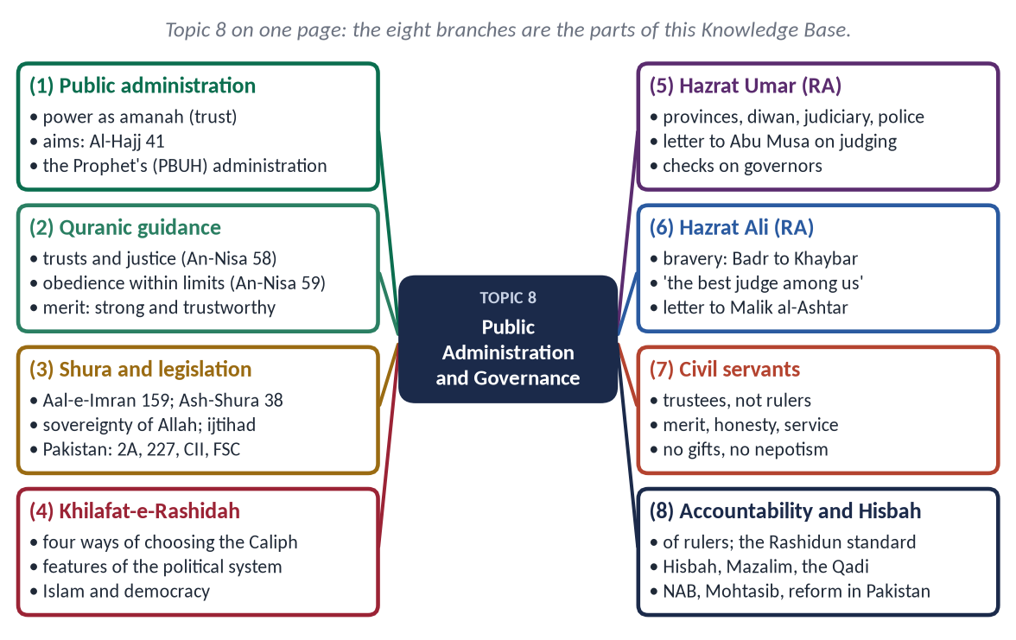
Figure 1 · Topic 8 on one page. The eight branches are the parts of this Knowledge Base.

How this document is built
1. Part Zero — the ABC: the words of the topic and the basic frame.
2. Part One — ten chapters. In every point the evidence comes Quran → Hadith → the Rightly-Guided Caliphs and jurists → scholars, law and data.
3. At-a-glance charts after long sections, giving the names only.
4. Part Two — contemporary challenges and hot debates.
5. Part Three — the examiner's record and five likely questions.
6. Part Four — the numbered one-liner bank.
7. Part Five — section-by-section revision notes.
EXAMINER'S EYE · THIS TOPIC IN THE PAPER
The examiner wants three things in every governance answer. First, the principle, from the Quran and Sunnah. Second, the model: the Prophet ﷺ and the Rightly-Guided Caliphs, with named examples. Third, the application to Pakistan: NAB, the Mohtasib, the civil service, the Constitution. An answer that gives only principles reads like a sermon. One that gives only Pakistan reads like a newspaper. Give all three.

TRAP · STAY WITH THE RASHIDUN, STAY NEUTRAL
Build on the Prophet ﷺ and the four Rightly-Guided Caliphs, whom all Muslims honour. Do not take sides in the political disputes of early Islam or of today's parties. Criticise practices (nepotism, selective accountability), not persons or parties.

Part Zero — The ABC Before the Chapters

0.1 The words of this topic
Term | Arabic | Meaning in this topic
Idarah | إِدَارَة | Administration, management.
Siyasah Shar'iyyah | سِيَاسَة شَرْعِيَّة | Governance according to the Shari'ah — policy that serves the people within Allah's limits.
Khilafah | خِلَافَة | Vicegerency. Man is Allah's khalifah on earth; also the office of the Caliph.
Imamah | إِمَامَة | Leadership of the Muslim community; the head of state.
Amanah | أَمَانَة | A trust. Every office is a trust (An-Nisa 58).
'Adl | عَدْل | Justice — the first aim of government.
Shura | شُورَىٰ | Consultation (Ash-Shura 38).
Bay'ah | بَيْعَة | The pledge of allegiance — the people's consent to the ruler.
Ahl al-Hall wa al-'Aqd | أَهْلُ الْحَلِّ وَالْعَقْد | 'Those who loosen and bind' — the representatives who choose and advise the ruler.
Ulu al-Amr | أُولُو الْأَمْر | Those in authority (An-Nisa 59).
Muhasabah | مُحَاسَبَة | Accountability; taking to account.
Hisbah | حِسْبَة | The institution that enjoins good and forbids wrong in public life, especially the market.
Muhtasib | مُحْتَسِب | The officer of Hisbah; in Pakistan, the Mohtasib (Ombudsman).
Mazalim | مَظَالِم | The court of grievances against officials.
Qadi | قَاضِي | Judge.
Wali / 'Amil | وَالِي / عَامِل | Governor / official, revenue collector.
Bayt al-Mal | بَيْتُ الْمَال | The public treasury.
Diwan | دِيوَان | The register of stipends; later, a government department.
Ghulul | غُلُول | Embezzlement of public property.
Rashwah | رِشْوَة | Bribery.

0.2 The frame in one line
Sovereignty belongs to Allah; authority is a trust held by the people and their chosen rulers; government is service; every office-holder is accountable to Allah, to the law and to the people. The same frame appears in the Objectives Resolution (1949) and Article 2A of the Constitution of Pakistan.

Chapter 1 · The Concept of Public Administration in Islam
The first limb of 2016: 'Highlight the concept of Public Administration in Islam.'

1.1 Meaning
Public administration is the organisation and management of the state's resources and people to deliver public services: law and order, justice, revenue, welfare and development. In Islam it is idarah (إِدَارَة) under siyasah shar'iyyah (سِيَاسَة شَرْعِيَّة). It is the running of public affairs as an amanah (trust), to achieve the aims of the Shari'ah, under accountability to Allah and to the people.
✦ QURAN
﴿… إِنِّي جَاعِلٞ فِي ٱلۡأَرۡضِ خَلِيفَةٗۖ …﴾
“Indeed, I will make upon the earth a vicegerent (khalifah).” (Al-Baqarah, Quran)
➜ 'I am placing on the earth a khalifah (a vicegerent).'

1.2 The aims of public administration in Islam
✦ QURAN
﴿ٱلَّذِينَ إِن مَّكَّنَّـٰهُمۡ فِي ٱلۡأَرۡضِ أَقَامُواْ ٱلصَّلَوٰةَ وَءَاتَوُاْ ٱلزَّكَوٰةَ وَأَمَرُواْ بِٱلۡمَعۡرُوفِ وَنَهَوۡاْ عَنِ ٱلۡمُنكَرِۗ وَلِلَّهِ عَٰقِبَةُ ٱلۡأُمُورِ﴾
“[And they are] those who, if We give them authority in the land, establish prayer and give zakah and enjoin what is right and forbid what is wrong. And to Allah belongs the outcome of [all] matters.” (Al-Hajj, Quran)
➜ Those who, if We establish them in the land, establish prayer, give zakat, enjoin good and forbid evil.

From this verse and the Maqasid al-Shari'ah, the aims are:
- (a) Establishing justice — 'We sent Our messengers … so that people may uphold justice' (Al-Hadid 25).
- (b) Protecting the five essentials — life, faith, intellect, lineage and property.
- (c) Welfare — Zakat, stipends and relief for the poor, orphans and travellers.
- (d) Order and security — so that people may live, work and worship in peace (Quraysh 3–4: 'who fed them against hunger and secured them from fear').
- (e) Enjoining good and forbidding wrong — through law, education and Hisbah.
- (f) Development — roads, canals, markets, learning.

1.3 The principles of Islamic public administration
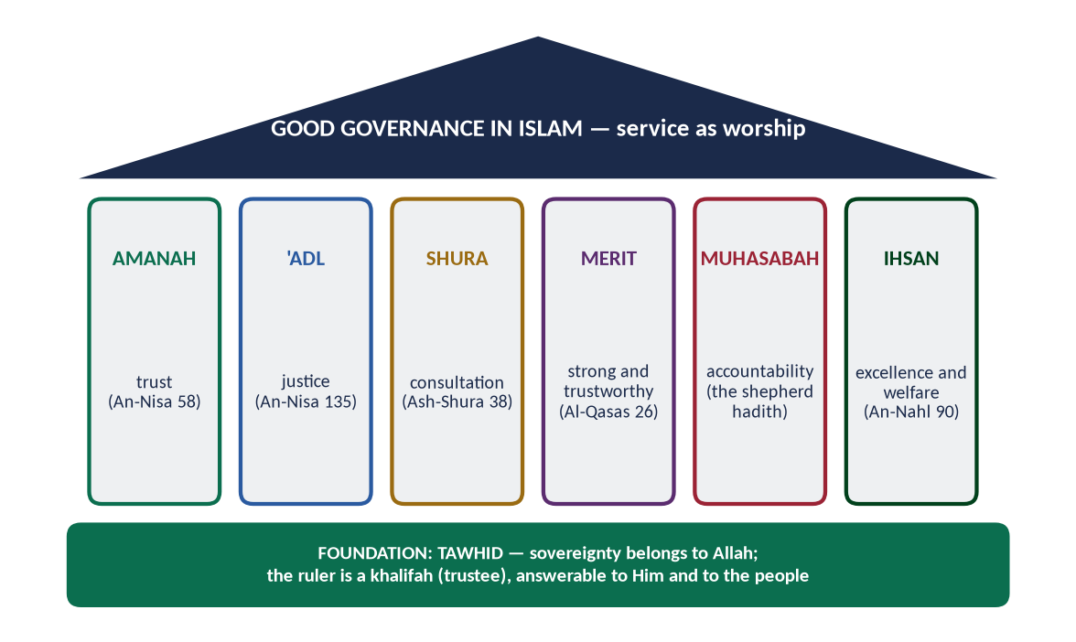
Figure 2 · The pillars of good governance in Islam, on the foundation of Tawhid.

(1) Tawhid — the foundation
Sovereignty belongs to Allah. The ruler is not above the law; he is a servant of the law.
✦ QURAN
﴿… إِنِ ٱلۡحُكۡمُ إِلَّا لِلَّهِ أَمَرَ أَلَّا تَعۡبُدُوٓاْ إِلَّآ إِيَّاهُۚ …﴾
“The judgement belongs only to Allah. He has commanded that you worship none but Him.” (Yusuf, Quran)
➜ 'The judgement belongs only to Allah.' (Yusuf 40)

(2) Amanah — office as a trust
✦ QURAN
﴿إِنَّ ٱللَّهَ يَأۡمُرُكُمۡ أَن تُؤَدُّواْ ٱلۡأَمَٰنَٰتِ إِلَىٰٓ أَهۡلِهَا وَإِذَا حَكَمۡتُم بَيۡنَ ٱلنَّاسِ أَن تَحۡكُمُواْ بِٱلۡعَدۡلِۚ …﴾
“Indeed, Allah commands you to render trusts to those entitled to them, and when you judge between people, to judge with justice.” (An-Nisa, Quran)
➜ Allah commands you to render trusts to those entitled to them, and when you judge between people, to judge with justice.

✦ HADITH
يَا أَبَا ذَرٍّ، إِنَّكَ ضَعِيفٌ، وَإِنَّهَا أَمَانَةٌ، وَإِنَّهَا يَوْمَ الْقِيَامَةِ خِزْيٌ وَنَدَامَةٌ، إِلَّا مَنْ أَخَذَهَا بِحَقِّهَا وَأَدَّى الَّذِي عَلَيْهِ فِيهَا
“O Abu Dharr, you are weak, and it (office) is a trust. On the Day of Resurrection it will be disgrace and regret, except for the one who takes it by right and fulfils its duties.” (Muslim)
➜ Even a great Companion was refused office because he was not suited to it.

(3) 'Adl — justice
✦ QURAN
﴿إِنَّ ٱللَّهَ يَأۡمُرُ بِٱلۡعَدۡلِ وَٱلۡإِحۡسَٰنِ وَإِيتَآيِٕ ذِي ٱلۡقُرۡبَىٰ وَيَنۡهَىٰ عَنِ ٱلۡفَحۡشَآءِ وَٱلۡمُنكَرِ وَٱلۡبَغۡيِۚ يَعِظُكُمۡ لَعَلَّكُمۡ تَذَكَّرُونَ﴾
“Indeed, Allah orders justice and good conduct and giving to relatives and forbids immorality and bad conduct and oppression. He admonishes you that perhaps you will be reminded.” (An-Nahl, Quran)
➜ Allah commands justice and excellence (ihsan) and giving to relatives.

(4) Shura — consultation
✦ QURAN
﴿وَٱلَّذِينَ ٱسۡتَجَابُواْ لِرَبِّهِمۡ وَأَقَامُواْ ٱلصَّلَوٰةَ وَأَمۡرُهُمۡ شُورَىٰ بَيۡنَهُمۡ وَمِمَّا رَزَقۡنَٰهُمۡ يُنفِقُونَ﴾
“And those who have responded to their lord and established prayer and whose affair is [determined by] consultation among themselves, and from what We have provided them, they spend.” (Ash-Shura, Quran)
➜ Their affairs are by consultation among themselves.

(5) Merit — the right person for the right post
✦ QURAN
﴿قَالَتۡ إِحۡدَىٰهُمَا يَـٰٓأَبَتِ ٱسۡتَـٔۡجِرۡهُۖ إِنَّ خَيۡرَ مَنِ ٱسۡتَـٔۡجَرۡتَ ٱلۡقَوِيُّ ٱلۡأَمِينُ﴾
“One of the women said, "O my father, hire him. Indeed, the best one you can hire is the strong and the trustworthy.” (Al-Qasas, Quran)
➜ 'The best one you can hire is the strong and the trustworthy.' (Al-Qasas 26)

✦ HADITH
إِذَا وُسِّدَ الْأَمْرُ إِلَى غَيْرِ أَهْلِهِ فَانْتَظِرِ السَّاعَةَ
“When authority is given to those not fit for it, then wait for the Hour.” (Al-Bukhari)
➜ Nepotism is a sign of a society's collapse.

(6) Accountability
✦ HADITH
كُلُّكُمْ رَاعٍ وَكُلُّكُمْ مَسْئُولٌ عَنْ رَعِيَّتِهِ، الْإِمَامُ رَاعٍ وَمَسْئُولٌ عَنْ رَعِيَّتِهِ
“Each of you is a shepherd and each is responsible for his flock. The ruler is a shepherd and responsible for his flock.” (Al-Bukhari and Muslim)

(7) Service and accessibility
✦ HADITH
مَنْ وَلَّاهُ اللَّهُ عَزَّ وَجَلَّ شَيْئًا مِنْ أَمْرِ الْمُسْلِمِينَ فَاحْتَجَبَ دُونَ حَاجَتِهِمْ وَخَلَّتِهِمْ وَفَقْرِهِمْ، احْتَجَبَ اللَّهُ عَنْهُ دُونَ حَاجَتِهِ وَخَلَّتِهِ وَفَقْرِهِ
“Whoever Allah puts in charge of the Muslims' affairs and he shuts himself away from their needs and poverty, Allah will shut Himself away from his needs and poverty.” (Abu Dawud)
➜ The Islamic rule against inaccessible officers.

(8) Ihsan — excellence in work
✦ HADITH
إِنَّ اللَّهَ كَتَبَ الْإِحْسَانَ عَلَى كُلِّ شَيْءٍ
“Allah has prescribed excellence in everything.” (Muslim)

(9) Simplicity and austerity
The Prophet ﷺ and the Caliphs lived like ordinary citizens. Hazrat Umar (RA) wore patched clothes and slept under a tree without guards. The Persian envoy's surprise at seeing him that way is a famous report.

(10) Welfare of all citizens
Non-Muslim citizens (dhimmis) were protected. Hazrat Umar (RA) gave a stipend from the Bayt al-Mal to an old, blind Jewish beggar (Abu Yusuf, Kitab al-Kharaj).

1.4 The administration of the Prophet ﷺ in Madinah
The Prophet ﷺ founded the first Islamic state and its administration:
- A written constitution — the Charter of Madinah (622), with rights and duties for all communities.
- Governors and judges — Mu'adh ibn Jabal (RA) to Yemen; 'Attab ibn Asid (RA) to Makkah (630).
- Secretaries — Zayd ibn Thabit (RA) and others wrote letters, treaties and records.
- Revenue officers — collectors of Zakat, checked on return (the case of Ibn al-Lutbiyyah).
- Market inspection — he inspected the grain himself: 'whoever cheats is not of me' (Muslim).
- Diplomacy — envoys to kings (628 onwards), treaties (Hudaybiyyah).
- Defence — volunteers organised under appointed commanders.
- Census — he ordered a count of the Muslims (Al-Bukhari).
✦ HADITH
كَيْفَ تَقْضِي إِذَا عَرَضَ لَكَ قَضَاءٌ؟ قَالَ: أَقْضِي بِكِتَابِ اللَّهِ ... فَبِسُنَّةِ رَسُولِ اللَّهِ ... أَجْتَهِدُ رَأْيِي وَلَا آلُو
“'How will you judge?' — 'By the Book of Allah … then the Sunnah … then I will use my own judgement and spare no effort.'” (Abu Dawud and Al-Tirmidhi)
➜ The Prophet ﷺ approved Mu'adh's method — the first instruction to a civil officer.

1.5 Islamic and modern public administration compared
Point | Modern public administration | Islamic public administration
Source of authority | The people / the constitution | Allah; the people as trustees
Motive of the officer | Salary, career | Salary + worship (ihsan) + the Hereafter
Accountability | Law, audit, media | The same + accountability before Allah
Ethics | Codes of conduct | Taqwa, amanah, ihsan — internal and external
Aim | Efficiency, service | Justice, welfare, the Maqasid
Selection | Merit tests | Merit + character ('strong and trustworthy')

Islam accepts the modern tools: exams, audit, records, e-governance. It adds the inner check of taqwa, which no audit can replace.
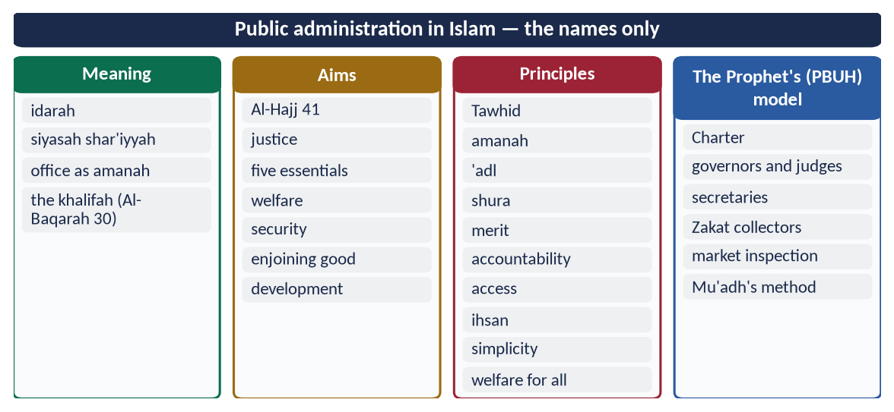
Figure 3 · At a glance — public administration in Islam — the names only. The detail is in the sections above.

Chapter 2 · Quranic Guidance on Good Governance
A syllabus line never asked yet, and so a strong likely question.

2.1 What 'good governance' means
The UN and the World Bank describe good governance by eight marks: participation, rule of law, transparency, responsiveness, consensus, equity, effectiveness and accountability. The Quran gave every one of these fourteen centuries ago, with a stronger base: the fear of Allah.

2.2 The Quranic principles

(1) Trusts to the deserving, and justice — the 'verse of governance'
✦ QURAN
﴿إِنَّ ٱللَّهَ يَأۡمُرُكُمۡ أَن تُؤَدُّواْ ٱلۡأَمَٰنَٰتِ إِلَىٰٓ أَهۡلِهَا وَإِذَا حَكَمۡتُم بَيۡنَ ٱلنَّاسِ أَن تَحۡكُمُواْ بِٱلۡعَدۡلِۚ …﴾
“Indeed, Allah commands you to render trusts to those entitled to them, and when you judge between people, to judge with justice.” (An-Nisa, Quran)
➜ Allah commands you to render trusts to those entitled to them, and when you judge between people, to judge with justice.

Scholars call An-Nisa 58–59 the verses of the rulers (ayat al-umara): verse 58 is addressed to the rulers, verse 59 to the ruled.

(2) Obedience within the law, and a constitutional reference
✦ QURAN
﴿يَـٰٓأَيُّهَا ٱلَّذِينَ ءَامَنُوٓاْ أَطِيعُواْ ٱللَّهَ وَأَطِيعُواْ ٱلرَّسُولَ وَأُوْلِي ٱلۡأَمۡرِ مِنكُمۡۖ فَإِن تَنَٰزَعۡتُمۡ فِي شَيۡءٖ فَرُدُّوهُ إِلَى ٱللَّهِ وَٱلرَّسُولِ إِن كُنتُمۡ تُؤۡمِنُونَ بِٱللَّهِ وَٱلۡيَوۡمِ ٱلۡأٓخِرِۚ ذَٰلِكَ خَيۡرٞ وَأَحۡسَنُ تَأۡوِيلًا﴾
“O you who believe, obey Allah and obey the Messenger and those in authority among you. If you disagree over anything, refer it to Allah and the Messenger … That is best and best in result.” (An-Nisa, Quran)
➜ Obedience to rulers is conditional, and disputes go to a higher law. This is the basis of the rule of law and judicial review.

(3) Justice even against oneself
✦ QURAN
﴿يَـٰٓأَيُّهَا ٱلَّذِينَ ءَامَنُواْ كُونُواْ قَوَّـٰمِينَ بِٱلۡقِسۡطِ شُهَدَآءَ لِلَّهِ وَلَوۡ عَلَىٰٓ أَنفُسِكُمۡ أَوِ ٱلۡوَٰلِدَيۡنِ وَٱلۡأَقۡرَبِينَۚ …﴾
“O you who believe, stand firmly for justice, as witnesses for Allah, even if it be against yourselves, your parents or your relatives.” (An-Nisa, Quran)
➜ Stand firm for justice, as witnesses for Allah, even against yourselves, your parents or relatives.

✦ QURAN
﴿… وَلَا يَجۡرِمَنَّكُمۡ شَنَـَٔانُ قَوۡمٍ عَلَىٰٓ أَلَّا تَعۡدِلُواْۚ ٱعۡدِلُواْ هُوَ أَقۡرَبُ لِلتَّقۡوَىٰۖ …﴾
“Do not let the hatred of a people lead you to be unjust. Be just; that is nearer to righteousness.” (Al-Ma'idah, Quran)
➜ Do not let the hatred of a people lead you to injustice. Be just; that is nearer to righteousness.

(4) Consultation
✦ QURAN
﴿فَبِمَا رَحۡمَةٖ مِّنَ ٱللَّهِ لِنتَ لَهُمۡۖ وَلَوۡ كُنتَ فَظًّا غَلِيظَ ٱلۡقَلۡبِ لَٱنفَضُّواْ مِنۡ حَوۡلِكَۖ …﴾
“So by mercy from Allah you were gentle with them; had you been harsh and hard-hearted, they would have scattered from around you.” (Aal-e-Imran, Quran)
➜ By Allah's mercy you were gentle with them … consult them in the matter, and when you have decided, rely upon Allah.

(5) Merit and competence
✦ QURAN
﴿قَالَتۡ إِحۡدَىٰهُمَا يَـٰٓأَبَتِ ٱسۡتَـٔۡجِرۡهُۖ إِنَّ خَيۡرَ مَنِ ٱسۡتَـٔۡجَرۡتَ ٱلۡقَوِيُّ ٱلۡأَمِينُ﴾
“One of the women said, "O my father, hire him. Indeed, the best one you can hire is the strong and the trustworthy.” (Al-Qasas, Quran)
➜ 'The best one you can hire is the strong and the trustworthy.'

✦ QURAN
﴿قَالَ ٱجۡعَلۡنِي عَلَىٰ خَزَآئِنِ ٱلۡأَرۡضِۖ إِنِّي حَفِيظٌ عَلِيمٞ﴾
“[Joseph] said, "Appoint me over the storehouses of the land. Indeed, I will be a knowing guardian.” (Yusuf, Quran)
➜ Yusuf said, 'Put me in charge of the storehouses of the land; I am a knowing guardian (hafiz 'alim).'

(6) Honesty with public money
✦ QURAN
﴿وَمَا كَانَ لِنَبِيٍّ أَن يَغُلَّۚ وَمَن يَغۡلُلۡ يَأۡتِ بِمَا غَلَّ يَوۡمَ ٱلۡقِيَٰمَةِۚ ثُمَّ تُوَفَّىٰ كُلُّ نَفۡسٖ مَّا كَسَبَتۡ وَهُمۡ لَا يُظۡلَمُونَ﴾
“It is not [attributable] to any prophet that he would act unfaithfully [in regard to war booty]. And whoever betrays, [taking unlawfully], will come with what he took on the Day of Resurrection. Then will every soul be [fully] compensated for what it earned, and they will not be wronged.” (Aal-e-Imran, Quran)
➜ It is not for a prophet to act unfaithfully. Whoever betrays will bring what he took on the Day of Resurrection.

✦ QURAN
﴿وَلَا تَأۡكُلُوٓاْ أَمۡوَٰلَكُم بَيۡنَكُم بِٱلۡبَٰطِلِ وَتُدۡلُواْ بِهَآ إِلَى ٱلۡحُكَّامِ لِتَأۡكُلُواْ فَرِيقٗا مِّنۡ أَمۡوَٰلِ ٱلنَّاسِ بِٱلۡإِثۡمِ وَأَنتُمۡ تَعۡلَمُونَ﴾
“And do not consume one another's wealth unjustly or send it [in bribery] to the rulers in order that [they might aid] you [to] consume a portion of the wealth of the people in sin, while you know [it is unlawful].” (Al-Baqarah, Quran)
➜ Do not consume one another's wealth unjustly, nor offer it to the rulers (as bribes) to consume a portion of others' wealth sinfully.

(7) Economic justice
✦ QURAN
﴿… كَيۡ لَا يَكُونَ دُولَةَۢ بَيۡنَ ٱلۡأَغۡنِيَآءِ مِنكُمۡۚ …﴾
“… so that it does not circulate only among the rich among you.” (Al-Hashr, Quran)
➜ So that wealth does not circulate only among the rich among you.

(8) Verification and transparency
✦ QURAN
﴿يَـٰٓأَيُّهَا ٱلَّذِينَ ءَامَنُوٓاْ إِن جَآءَكُمۡ فَاسِقُۢ بِنَبَإٖ فَتَبَيَّنُوٓاْ أَن تُصِيبُواْ قَوۡمَۢا بِجَهَٰلَةٖ فَتُصۡبِحُواْ عَلَىٰ مَا فَعَلۡتُمۡ نَٰدِمِينَ﴾
“O you who have believed, if there comes to you a disobedient one with information, investigate, lest you harm a people out of ignorance and become, over what you have done, regretful.” (Al-Hujurat, Quran)
➜ If a sinful person brings you news, verify it.

(9) Fulfilling contracts and promises
✦ QURAN
﴿يَـٰٓأَيُّهَا ٱلَّذِينَ ءَامَنُوٓاْ أَوۡفُواْ بِٱلۡعُقُودِۚ …﴾
“O you who have believed, fulfil the contracts.” (Al-Ma'idah, Quran)
➜ 'O you who believe, fulfil your contracts.'

✦ QURAN
﴿… وَأَوۡفُواْ بِٱلۡعَهۡدِۖ إِنَّ ٱلۡعَهۡدَ كَانَ مَسۡـُٔولٗا﴾
“And fulfil every commitment; indeed, the commitment will be questioned about.” (Al-Isra, Quran)
➜ Fulfil every commitment; every commitment will be questioned.

(10) Accountability before Allah
✦ QURAN
﴿فَوَرَبِّكَ لَنَسۡـَٔلَنَّهُمۡ أَجۡمَعِينَ ۝ عَمَّا كَانُواْ يَعۡمَلُونَ﴾
“So by your Lord, We will surely question them all. About what they used to do.” (Al-Hijr, Quran)
➜ By your Lord, We will surely question them all about what they used to do.

✦ QURAN
﴿وَقِفُوهُمۡۖ إِنَّهُم مَّسۡـُٔولُونَ﴾
“And stop them; indeed, they are to be questioned.” (As-Saffat, Quran)
➜ 'Stop them; they are to be questioned.'

(11) Humility — power without arrogance
✦ QURAN
﴿تِلۡكَ ٱلدَّارُ ٱلۡأٓخِرَةُ نَجۡعَلُهَا لِلَّذِينَ لَا يُرِيدُونَ عُلُوّٗا فِي ٱلۡأَرۡضِ وَلَا فَسَادٗاۚ وَٱلۡعَٰقِبَةُ لِلۡمُتَّقِينَ﴾
“That home of the Hereafter We assign to those who do not desire exaltedness upon the earth or corruption. And the [best] outcome is for the righteous.” (Al-Qasas, Quran)
➜ That home of the Hereafter We give to those who seek neither superiority on earth nor corruption.

(12) The warning of bad governance — Pharaoh
✦ QURAN
﴿إِنَّ فِرۡعَوۡنَ عَلَا فِي ٱلۡأَرۡضِ وَجَعَلَ أَهۡلَهَا شِيَعٗا يَسۡتَضۡعِفُ طَآئِفَةٗ مِّنۡهُمۡ يُذَبِّحُ أَبۡنَآءَهُمۡ وَيَسۡتَحۡيِۦ نِسَآءَهُمۡۚ إِنَّهُۥ كَانَ مِنَ ٱلۡمُفۡسِدِينَ﴾
“Indeed, Pharaoh exalted himself in the land and made its people into factions, oppressing a sector among them, slaughtering their [newborn] sons and keeping their females alive. Indeed, he was of the corrupters.” (Al-Qasas, Quran)
➜ Pharaoh exalted himself in the land and divided its people into groups, oppressing one group of them.

2.3 Quranic models of good rulers
- Prophet Yusuf (AS) — an honest, skilled administrator. He saved Egypt from seven years of famine through planning and storage (Yusuf 47–49).
- Prophet Dawud (AS) — 'We made you a khalifah on earth, so judge between people in truth and do not follow desire' (Sad 26).
- Prophet Sulayman (AS) — power used with gratitude and justice, even for the ants (An-Naml 18–19).
- Dhul-Qarnayn — power used to protect the weak and build the barrier against Gog and Magog; he refused payment: 'what my Lord has given me is better' (Al-Kahf 95).
- The Queen of Sheba (Bilqis) — she consulted her council: 'I decide no matter until you are present' (An-Naml 32).

2.4 The Quranic principles against the UN's marks
Mark of good governance | Quranic guidance
Rule of law | An-Nisa 59: disputes referred to the higher law
Accountability | Al-Hijr 92–93; the shepherd hadith
Transparency | Al-Hujurat 6; Al-Baqarah 282 (write down transactions)
Participation and consensus | Ash-Shura 38; Aal-e-Imran 159
Equity | Al-Hashr 7; An-Nisa 135
Effectiveness | Al-Qasas 26; Yusuf 55
Responsiveness | 'Whoever shuts himself away from their needs' (Abu Dawud)
Integrity | Aal-e-Imran 161; Al-Baqarah 188

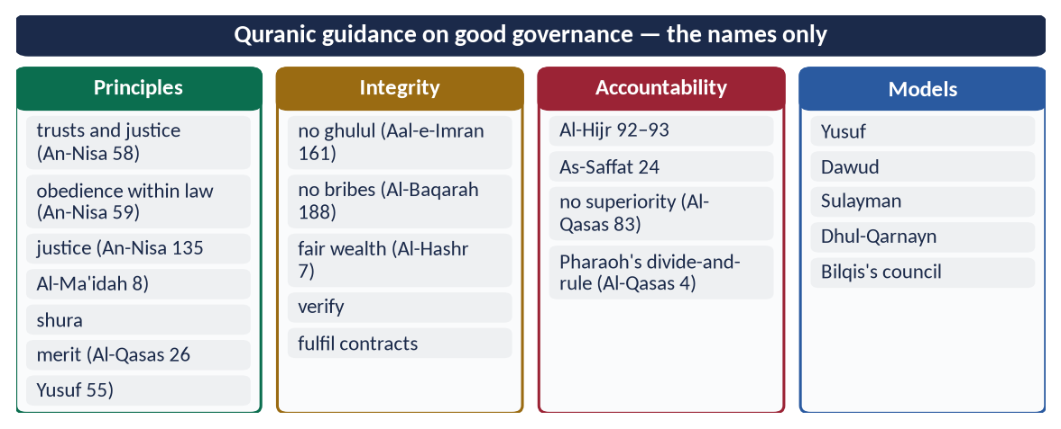
Figure 4 · At a glance — quranic guidance on good governance — the names only. The detail is in the sections above.

Chapter 3 · Governance in the Quran, Sunnah and Fiqh
The syllabus line 'Concept of governance and its applications in the light of Qur'an, Sunnah and Fiqh'. It is the base for 2016 Q7 (the Islamic political system) and 2019 (reforming Pakistani politics).

3.1 The concept of governance
Governance is the way power is exercised in managing a country's affairs: how rulers are chosen, how decisions are made, how resources are used, and how rulers are checked. In Islam governance rests on three relationships:
- Allah and the ruler — the ruler is a khalifah (trustee), bound by Allah's law.
- The ruler and the people — a contract (bay'ah). The people obey in what is right; the ruler serves, consults and answers to them.
- The ruler and the law — the ruler is under the law, never above it.

3.2 Governance in the Quran — the foundations
✦ QURAN
﴿وَعَدَ ٱللَّهُ ٱلَّذِينَ ءَامَنُواْ مِنكُمۡ وَعَمِلُواْ ٱلصَّـٰلِحَٰتِ لَيَسۡتَخۡلِفَنَّهُمۡ فِي ٱلۡأَرۡضِ كَمَا ٱسۡتَخۡلَفَ ٱلَّذِينَ مِن قَبۡلِهِمۡ …﴾
“Allah has promised those who believe and do righteous deeds that He will make them successors (khulafa') in the land, as He made those before them.” (An-Nur, Quran)
➜ Governance is a promise tied to faith and righteous deeds, not to race or family.

✦ QURAN
﴿قُلِ ٱللَّهُمَّ مَٰلِكَ ٱلۡمُلۡكِ تُؤۡتِي ٱلۡمُلۡكَ مَن تَشَآءُ وَتَنزِعُ ٱلۡمُلۡكَ مِمَّن تَشَآءُ …﴾
“Say: O Allah, Owner of sovereignty, You give sovereignty to whom You will and take sovereignty away from whom You will.” (Aal-e-Imran, Quran)
➜ Say: O Allah, Owner of sovereignty, You give sovereignty to whom You will and take it from whom You will.

✦ QURAN
﴿يَٰدَاوُۥدُ إِنَّا جَعَلۡنَٰكَ خَلِيفَةٗ فِي ٱلۡأَرۡضِ فَٱحۡكُم بَيۡنَ ٱلنَّاسِ بِٱلۡحَقِّ وَلَا تَتَّبِعِ ٱلۡهَوَىٰ فَيُضِلَّكَ عَن سَبِيلِ ٱللَّهِۚ …﴾
“O Dawud, We have made you a vicegerent on the earth, so judge between people in truth and do not follow desire, lest it lead you astray from the way of Allah.” (Sad, Quran)
➜ 'O Dawud, We have made you a khalifah on earth, so judge between people in truth and do not follow desire.'

✦ QURAN
﴿يَـٰٓأَيُّهَا ٱلَّذِينَ ءَامَنُوٓاْ أَطِيعُواْ ٱللَّهَ وَأَطِيعُواْ ٱلرَّسُولَ وَأُوْلِي ٱلۡأَمۡرِ مِنكُمۡۖ …﴾
“Obey Allah and obey the Messenger and those in authority among you.” (An-Nisa, Quran)

From these verses come the Quran's five foundations of governance:
- (a) sovereignty belongs to Allah;
- (b) authority is a trust (khilafah);
- (c) justice is the aim;
- (d) consultation is the method;
- (e) obedience is conditional on the law.

3.3 Governance in the Sunnah — the state of Madinah

(1) A state by agreement
The Prophet ﷺ did not seize power. The people of Madinah invited him through the Pledges of 'Aqabah (621, 622). The Charter of Madinah (622) then created a state by written agreement among Muslims, Jews and others.

(2) Rule of law and equality
✦ HADITH
إِنَّمَا أَهْلَكَ الَّذِينَ قَبْلَكُمْ أَنَّهُمْ كَانُوا إِذَا سَرَقَ فِيهِمُ الشَّرِيفُ تَرَكُوهُ، وَإِذَا سَرَقَ فِيهِمُ الضَّعِيفُ أَقَامُوا عَلَيْهِ الْحَدَّ، وَايْمُ اللَّهِ لَوْ أَنَّ فَاطِمَةَ بِنْتَ مُحَمَّدٍ سَرَقَتْ لَقَطَعْتُ يَدَهَا
“Those before you were destroyed because when a noble person stole they let him go, and when a weak person stole they punished him. By Allah, if Fatimah the daughter of Muhammad stole, I would cut off her hand.” (Al-Bukhari and Muslim)
➜ Said when the Quraysh sought pardon for a noble woman of Banu Makhzum. It is the charter of equality before law.

(3) Consultation
✦ HADITH
مَا رَأَيْتُ أَحَدًا أَكْثَرَ مَشُورَةً لِأَصْحَابِهِ مِنْ رَسُولِ اللَّهِ ﷺ
“I never saw anyone consult his companions more than the Messenger of Allah ﷺ.” (Al-Tirmidhi)
➜ Abu Hurayrah (RA).

(4) Mercy in authority
✦ HADITH
اللَّهُمَّ مَنْ وَلِيَ مِنْ أَمْرِ أُمَّتِي شَيْئًا فَشَقَّ عَلَيْهِمْ فَاشْقُقْ عَلَيْهِ، وَمَنْ وَلِيَ مِنْ أَمْرِ أُمَّتِي شَيْئًا فَرَفَقَ بِهِمْ فَارْفُقْ بِهِ
“O Allah, whoever takes charge of any affair of my Ummah and is harsh with them, be harsh with him; and whoever takes charge and is gentle with them, be gentle with him.” (Muslim)

(5) Honesty to the people
✦ HADITH
مَا مِنْ عَبْدٍ يَسْتَرْعِيهِ اللَّهُ رَعِيَّةً، يَمُوتُ يَوْمَ يَمُوتُ وَهُوَ غَاشٌّ لِرَعِيَّتِهِ، إِلَّا حَرَّمَ اللَّهُ عَلَيْهِ الْجَنَّةَ
“There is no servant whom Allah places in charge of people, who dies on the day he dies while deceiving his people, except that Allah forbids Paradise for him.” (Muslim)

(6) The best and worst rulers
✦ HADITH
خِيَارُ أَئِمَّتِكُمُ الَّذِينَ تُحِبُّونَهُمْ وَيُحِبُّونَكُمْ، وَيُصَلُّونَ عَلَيْكُمْ وَتُصَلُّونَ عَلَيْهِمْ
“The best of your rulers are those whom you love and who love you, who pray for you and for whom you pray.” (Muslim)

✦ HADITH
سَبْعَةٌ يُظِلُّهُمُ اللَّهُ فِي ظِلِّهِ يَوْمَ لَا ظِلَّ إِلَّا ظِلُّهُ: الْإِمَامُ الْعَادِلُ ...
“Seven whom Allah will shade on the Day when there is no shade but His: the just ruler …” (Al-Bukhari and Muslim)
➜ The just ruler is first in the list.

3.4 Governance in Fiqh — the jurists' contribution
The jurists turned the Quran and Sunnah into a science of government, al-siyasah al-shar'iyyah and al-ahkam al-sultaniyyah:
Jurist and work | Contribution
Imam Abu Yusuf (d. 798), Kitab al-Kharaj | Written for Caliph Harun al-Rashid: taxation, land revenue, the treasury, the rights of non-Muslim citizens, and advice to the ruler. The first manual of Islamic public finance, from the Hanafi school.
Imam Muhammad al-Shaybani (d. 805), Al-Siyar | International law: war, treaties, envoys and the rights of foreigners.
Al-Mawardi (d. 1058), Al-Ahkam al-Sultaniyyah | The classic of constitutional law: qualifications and election of the Imam, the duties of the ruler, ministers, governors, judges, Hisbah and Mazalim.
Al-Ghazali (d. 1111), Nasihat al-Muluk | Advice to kings: justice, accessibility, the dangers of oppression.
Ibn Khaldun (d. 1406), Al-Muqaddimah | 'Asabiyyah (social cohesion); the rise and fall of states; injustice ruins civilisation; the harm of heavy taxation.

✦ SCHOLARLY VIEW
Al-Mawardi · Al-Ahkam al-Sultaniyyah
The Imamate is instituted to succeed the Prophethood in guarding the religion and managing the affairs of the world.
➜ The classical definition of the purpose of the state.

The ten duties of the ruler (al-Mawardi)
1. Protect the religion on its established principles.
2. Settle disputes and enforce judgements (justice).
3. Protect the land and keep the roads safe.
4. Enforce the legal punishments so that rights are protected.
5. Guard the borders.
6. Invite to Islam and defend it (jihad under the state).
7. Collect Zakat and lawful revenue.
8. Pay stipends and expenses from the treasury fairly, without waste or delay.
9. Appoint trustworthy and competent officials.
10. Personally supervise the affairs of the state and not leave everything to deputies.

Legal maxims (qawa'id) used in governance
- 'The ruler's actions over his subjects are bound by their welfare' — تَصَرُّفُ الْإِمَامِ عَلَى الرَّعِيَّةِ مَنُوطٌ بِالْمَصْلَحَةِ. Every policy must serve the public good.
- 'Harm is removed' — الضَّرَرُ يُزَالُ, from the hadith 'no harm and no returning of harm' (Ibn Majah).
- 'Necessity makes the forbidden permissible', within limits, in emergencies.
- 'Custom is authoritative' — العَادَةُ مُحَكَّمَةٌ — local practice counts where the text is silent.

3.5 Applications today
Principle | Modern application
Consultation | Parliament; cabinet; local government; public consultation on laws
Rule of law | An independent judiciary; judicial review; no immunity for corruption
Trust and merit | Public Service Commissions; competitive exams (the CSS itself)
Accountability | Audit, ombudsmen, anti-corruption bodies, a free press
Welfare | Zakat and Ushr; Bait-ul-Mal; social protection (BISP)
Maslahah | Policy based on evidence and public interest

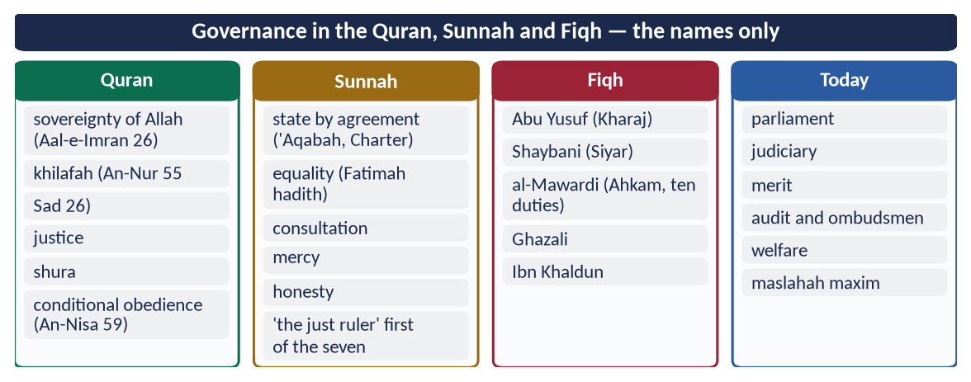
Figure 5 · At a glance — governance in the Quran, Sunnah and Fiqh — the names only. The detail is in the sections above.

Chapter 4 · The Structure of Governance: Shura and Legislation
The syllabus line 'Governance structure in Islam (Shura, Legislation, Sources of Islamic Law)'. The sources of law are taught in Topic 9 with Ijma and Ijtihad; here we teach Shura and legislation.

4.1 The meaning of Shura
Shura (شُورَىٰ), from shawara, means to extract honey from the hive. The best opinion is drawn from many minds.
✦ QURAN
﴿وَٱلَّذِينَ ٱسۡتَجَابُواْ لِرَبِّهِمۡ وَأَقَامُواْ ٱلصَّلَوٰةَ وَأَمۡرُهُمۡ شُورَىٰ بَيۡنَهُمۡ وَمِمَّا رَزَقۡنَٰهُمۡ يُنفِقُونَ﴾
“And those who have responded to their lord and established prayer and whose affair is [determined by] consultation among themselves, and from what We have provided them, they spend.” (Ash-Shura, Quran)
➜ Those who respond to their Lord, establish prayer, and whose affairs are by consultation among themselves, and spend from what We have provided them.

✦ QURAN
﴿فَبِمَا رَحۡمَةٖ مِّنَ ٱللَّهِ لِنتَ لَهُمۡۖ وَلَوۡ كُنتَ فَظًّا غَلِيظَ ٱلۡقَلۡبِ لَٱنفَضُّواْ مِنۡ حَوۡلِكَۖ …﴾
“So by mercy from Allah you were gentle with them; had you been harsh and hard-hearted, they would have scattered from around you.” (Aal-e-Imran, Quran)
➜ 'Consult them in the matter, and when you have decided, rely upon Allah.'

✦ HADITH
الْمُسْتَشَارُ مُؤْتَمَنٌ
“The one who is consulted is in a position of trust.” (Abu Dawud and Al-Tirmidhi)
➜ An adviser must give honest advice.

4.2 The Prophet's ﷺ practice of Shura
Occasion | The consultation
Badr (2 AH) | Whether to fight; the Ansar's reply (Sa'd ibn Mu'adh). Hubab ibn al-Mundhir asked, 'Is this position revelation or opinion?', then proposed a better site near the wells, which the Prophet ﷺ accepted.
Prisoners of Badr | Abu Bakr advised ransom, Umar advised execution; the Prophet ﷺ chose ransom (Muslim).
Uhud (3 AH) | He preferred to defend inside Madinah; the young majority wanted to go out. He followed the majority.
Khandaq (5 AH) | Salman al-Farsi's (RA) proposal of the trench, a Persian technique, was adopted.
Hudaybiyyah (6 AH) | When the Companions hesitated, Umm Salamah (RA) advised him to sacrifice first; they followed at once. A woman's advice solved a crisis.

Limits: there is no Shura on what Allah and His Messenger have decided (Al-Ahzab 36). Shura works in the vast area of permitted choices: policy, administration, war and peace, budgets and appointments.

4.3 Shura under the Rightly-Guided Caliphs
- Abu Bakr (RA) consulted on the campaign against those who refused Zakat, and on compiling the Quran (12 AH).
- Umar (RA) had a majlis al-shura of senior Muhajirun and Ansar, plus wider public meetings in the Mosque (announced by the call al-salatu jami'ah). On the conquered lands of Iraq and Syria he debated for days with the Companions and then with ten leaders of the Ansar. He decided to keep the land as state property for future generations, with the tax (kharaj) funding the state (Kitab al-Kharaj).
- Umar (RA) said: 'There is no Khilafah without consultation' (reported by Ibn Abi Shaybah).
- Uthman (RA) was chosen through the council of six; he consulted on the standard copy of the Quran.

4.4 Is Shura binding or advisory?
View | Argument
Advisory (mu'limah) | 'When you have decided, rely upon Allah' (Aal-e-Imran 159) — the final decision is the ruler's; Abu Bakr's decision on the Zakat-refusers against early doubts.
Binding (mulzimah) | The Prophet ﷺ followed the majority at Uhud against his own view; 'their affairs are by consultation' describes a collective decision; Abu Bakr and Umar consulted and generally acted on the consensus.
Today's majority view | In a modern state, Shura works through an elected parliament whose decisions, within the Constitution and Shari'ah, bind the government.

4.5 Legislation in an Islamic state

(1) The principle — Allah is the Lawgiver
✦ QURAN
﴿… إِنِ ٱلۡحُكۡمُ إِلَّا لِلَّهِ أَمَرَ أَلَّا تَعۡبُدُوٓاْ إِلَّآ إِيَّاهُۚ …﴾
“The judgement belongs only to Allah. He has commanded that you worship none but Him.” (Yusuf, Quran)
➜ 'The judgement belongs only to Allah. He has commanded that you worship none but Him.'

✦ QURAN
﴿… وَمَن لَّمۡ يَحۡكُم بِمَآ أَنزَلَ ٱللَّهُ فَأُوْلَـٰٓئِكَ هُمُ ٱلۡكَٰفِرُونَ﴾
“And whoever does not judge by what Allah has revealed — it is they who are the disbelievers.” (Al-Ma'idah, Quran)
➜ Whoever does not judge by what Allah has revealed — those are the disbelievers.

(2) Human legislation has a large lawful space
Human beings legislate:
- (a) to apply the revealed law in detail (procedure, penalties within limits, administration);
- (b) through Ijtihad where there is no clear text (Mu'adh's hadith);
- (c) in the mubah (permitted) area — traffic, taxes, education, health, trade — by maslahah (public interest);
- (d) by collective Ijtihad, which Iqbal proposed should pass to an elected Muslim legislative assembly (Reconstruction, Lecture VI).

(3) Legislation in Pakistan
Provision | What it does
Objectives Resolution (1949); Article 2A (1985) | Sovereignty belongs to Allah; authority is a sacred trust exercised by the people's representatives within His limits.
Article 2 | Islam is the state religion.
Article 227 | No law repugnant to the injunctions of Islam; existing laws to be brought into conformity.
Articles 228–231 | The Council of Islamic Ideology advises Parliament on the Islamic character of laws.
Article 203 (1980) | The Federal Shariat Court may strike down laws repugnant to Islam.
Article 31 | The Islamic way of life: teaching of the Quran, Zakat, promotion of Islamic values.

4.6 Separation of powers in the Islamic tradition
- Legislative — the Quran and Sunnah as the supreme law; Shura and Ijtihad for new law.
- Executive — the Caliph and his governors.
- Judicial — the Qadi. Umar (RA) separated the judiciary from the governors, appointing Shurayh to Kufa and others to Basra and Egypt. The Caliph himself appeared in court: Umar before Zayd ibn Thabit in a dispute with Ubayy ibn Ka'b; Ali before Shurayh in the case of the armour.
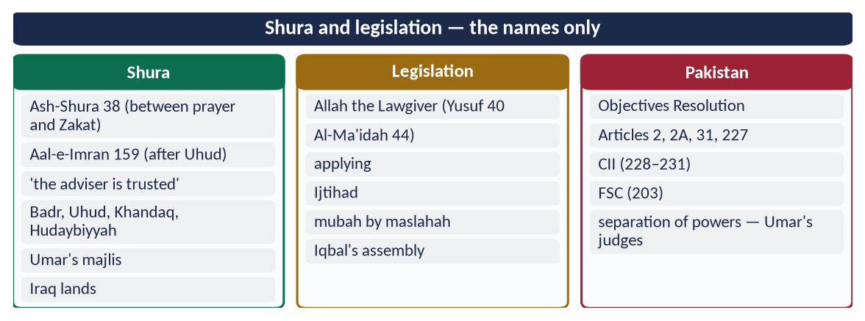
Figure 6 · At a glance — shura and legislation — the names only. The detail is in the sections above.

Chapter 5 · Governance under the Khilafat-e-Rashidah
The base of 2016 Q7 ('salient features of the Islamic political system in the light of governance under pious Khilafat') and 2017 Q4 ('How were the Rightly-Guided Caliphs elected? To what extent can their system be regarded as democratic?').

5.1 The Khilafat-e-Rashidah — the model period
The Khilafat-e-Rashidah (the Rightly-Guided Caliphate) is the rule of the four Caliphs after the Prophet ﷺ: Abu Bakr, Umar, Uthman and Ali (RA), 11–40 AH / 632–661 CE, about thirty years.
✦ HADITH
عَلَيْكُمْ بِسُنَّتِي وَسُنَّةِ الْخُلَفَاءِ الرَّاشِدِينَ الْمَهْدِيِّينَ، عَضُّوا عَلَيْهَا بِالنَّوَاجِذِ
“Hold to my Sunnah and the Sunnah of the Rightly-Guided Caliphs; bite on it with your molar teeth.” (Abu Dawud and Al-Tirmidhi)
➜ Their practice is a source of guidance for Muslim governance.

✦ HADITH
الْخِلَافَةُ فِي أُمَّتِي ثَلَاثُونَ سَنَةً، ثُمَّ مُلْكٌ بَعْدَ ذَلِكَ
“The Khilafah in my Ummah will be for thirty years; then there will be kingship after that.” (Abu Dawud and Al-Tirmidhi)
➜ Narrated by Safinah (RA); the thirty years match the four Caliphs (and the short rule of Hasan (RA)).

5.2 How the Caliphs were chosen (2017)
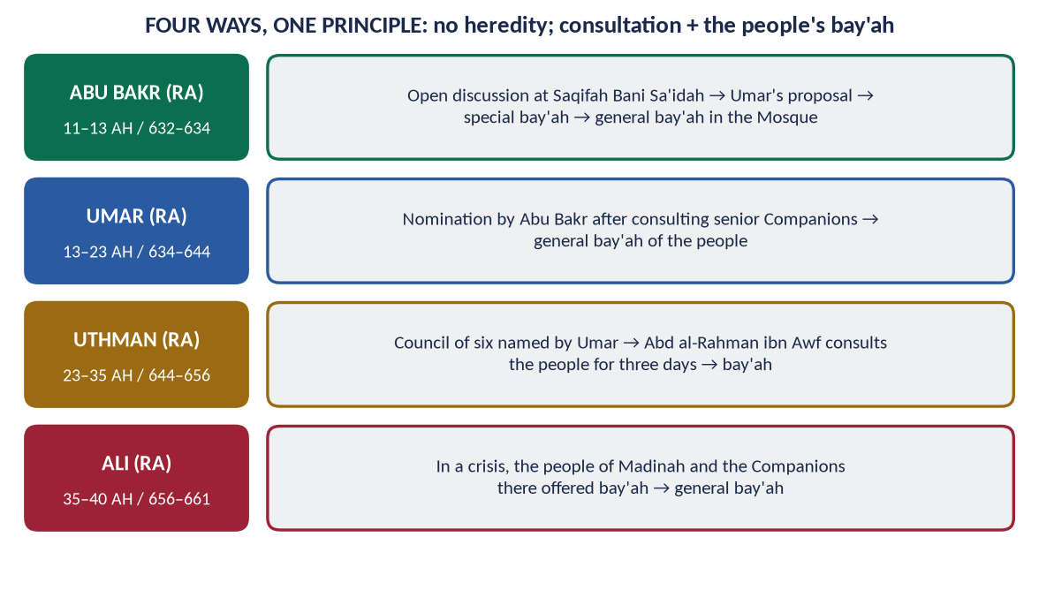
Figure 7 · Four ways of choosing the Caliph, one principle: no heredity; consultation and the people's bay'ah.

(1) Hazrat Abu Bakr (RA) — open discussion and election
- On the Prophet's ﷺ death (12 Rabi' al-Awwal 11 AH / June 632), the Ansar gathered at Saqifah Bani Sa'idah to choose a leader.
- Abu Bakr, Umar and Abu Ubaydah (RA) joined them. After open debate, Umar (RA) took Abu Bakr's hand and pledged allegiance, and the others followed. This was the special bay'ah (bay'ah khassah).
- The next day the people gave the general bay'ah (bay'ah 'ammah) in the Prophet's Mosque.
- Basis: his seniority, his companionship in the Cave (At-Tawbah 40), and his leading of the prayers in the Prophet's ﷺ last illness.
✦ FROM THE SIRAH
أَيُّهَا النَّاسُ، فَإِنِّي قَدْ وُلِّيتُ عَلَيْكُمْ وَلَسْتُ بِخَيْرِكُمْ، فَإِنْ أَحْسَنْتُ فَأَعِينُونِي، وَإِنْ أَسَأْتُ فَقَوِّمُونِي ... أَطِيعُونِي مَا أَطَعْتُ اللَّهَ وَرَسُولَهُ، فَإِذَا عَصَيْتُ اللَّهَ وَرَسُولَهُ فَلَا طَاعَةَ لِي عَلَيْكُمْ
“O people, I have been given authority over you, though I am not the best of you. If I do well, help me; if I do wrong, set me right … Obey me as long as I obey Allah and His Messenger; if I disobey them, you owe me no obedience.” (Ibn Hisham, Al-Sirah al-Nabawiyyah)
➜ The first inaugural address in Islam: a ruler under law and under the people's check. It also said: 'The weak among you is strong with me until I secure his right; the strong among you is weak with me until I take from him the right he owes.'

(2) Hazrat Umar (RA) — nomination after consultation, confirmed by the people
- In his final illness (13 AH / 634), Abu Bakr consulted senior Companions — Abd al-Rahman ibn Awf, Uthman and others — about Umar. Some worried about his strictness; Abu Bakr answered that responsibility would soften him.
- He had the nomination written down and read to the people, who gave their bay'ah.

(3) Hazrat Uthman (RA) — an electoral council
- Wounded in 23 AH / 644, Umar named a council of six: Uthman, Ali, Talhah, Zubayr, Sa'd ibn Abi Waqqas and Abd al-Rahman ibn Awf (RA). He barred his own son Abdullah from being chosen; he could only advise.
- The council was to decide within three days. Abd al-Rahman ibn Awf withdrew his own name and consulted the people for three days and nights: leaders, soldiers, travellers, even women in their homes (Al-Bukhari reports the consultation). The choice fell on Uthman, and the people gave bay'ah.

(4) Hazrat Ali (RA) — the bay'ah of the people in a crisis
- After Uthman's martyrdom (Dhul-Hijjah 35 AH / 656), the Companions in Madinah and the people urged Ali (RA) to accept. He insisted that the bay'ah be public, in the Mosque, not in secret.

(5) The principles common to all four
- No hereditary succession. None of the four made his son Caliph.
- Consultation of the leading men (ahl al-hall wa al-'aqd).
- Public consent through bay'ah.
- Merit: knowledge, piety, experience and ability.
- No self-seeking. None campaigned for power.

5.3 The salient features of the Islamic political system under the Rashidun (2016)
Feature | Evidence from the Rashidun
1. Sovereignty of Allah; rule of law | 'Obey me as long as I obey Allah' (Abu Bakr); the Caliph below the Shari'ah
2. Khilafah as a trust, not a kingdom | Umar: 'I am to your wealth like the guardian of an orphan: if rich, I take nothing; if poor, I take what is reasonable'
3. Election and consent (bay'ah) | The four methods above; no dynasty
4. Shura | Umar's majlis; the council of six; public meetings in the Mosque
5. Justice and equality before law | Umar and Ali appeared before judges as ordinary litigants
6. Independent judiciary | Qadis appointed separately from governors (Shurayh in Kufa)
7. Accountability | Public questioning; asset checks of governors; the Hajj hearings
8. Freedom of expression | A man told Umar, 'Fear Allah!'; Umar replied, 'There is no good in you if you do not say it, and no good in us if we do not hear it'
9. Fundamental rights | Life, property, honour, belief — for Muslims and non-Muslims
10. Rights of non-Muslims | The covenant of Jerusalem (638): churches and crosses protected
11. Welfare state | Stipends from the Diwan; allowances for children; care for the old and disabled
12. Public treasury as a trust | The Bayt al-Mal kept separate from the Caliph's own money
13. Simplicity of rulers | Abu Bakr's small stipend; Umar's patched clothes; Ali's plain living
14. Merit in appointments | Governors chosen for ability and integrity, removed on complaint

5.4 The governance of each Caliph — the highlights

(1) Hazrat Abu Bakr (RA), 632–634
- Unity and stability: he crushed the false prophets and the rebels (the Riddah wars) and insisted on Zakat: 'By Allah, I will fight whoever separates prayer from Zakat.'
- Usamah's army: he sent the expedition the Prophet ﷺ had prepared, keeping the Prophet's decision despite the crisis.
- The compilation of the Quran (after Yamamah, 12 AH), through Zayd ibn Thabit (RA).
- Personal honesty: his stipend was fixed by the Companions. When he became Caliph he still went to the market to trade, until Umar and Abu Ubaydah fixed a stipend so that he could give all his time to the state (Al-Bukhari). Before his death he ordered that what he had received be returned to the treasury from his own property. Umar said: 'He has made it hard for those who come after him.'

(2) Hazrat Umar (RA), 634–644
The builder of Islamic administration: provinces, diwan, judiciary, police, calendar, treasury (Chapter 6).

(3) Hazrat Uthman (RA), 644–656
- The standard copy of the Quran (about 25 AH / 645–650), sent to the provinces, preserved the Ummah's unity.
- The navy: the first Muslim fleet (under Mu'awiyah, governor of Syria); Cyprus (28 AH / 649).
- Expansion and public works: enlargement of the Prophet's Mosque; wells and water for the public; he had earlier bought the well of Rumah for the Muslims in the Prophet's ﷺ time.
- Accountability: when charges were raised against his governors, he answered them publicly and sent inspectors to the provinces (35 AH). He refused to let blood be shed to protect himself.

(4) Hazrat Ali (RA), 656–661
- Justice and austerity: equal distribution from the treasury; he refused privileges to his own relatives.
- Judicial excellence: 'the best judge among us' (Umar, in Al-Bukhari).
- Letters of instruction to governors, especially to Malik al-Ashtar (Chapter 7).
- Firmness with dialogue towards the Khawarij.

5.5 To what extent was the system democratic? (2017)

(1) Similarities with democracy
Democratic principle | Under the Rashidun
Government by consent | Bay'ah of the people; no ruler without it
Consultation / representation | Shura of the leading men; public meetings
Rule of law | The Caliph under the Shari'ah and the courts
Accountability | 'If I do wrong, set me right'; public questioning
Freedom of expression | Open criticism of the Caliph in the Mosque
Equality | 'If Fatimah stole …'; Umar and the Copt
Rights of minorities | Covenants with Christians and Jews
No hereditary rule | None of the four appointed his son

(2) Differences from Western democracy
- Sovereignty: in democracy the people are sovereign; in Islam Allah is sovereign and the people hold authority as a trust. A majority cannot make halal what Allah made haram.
- Qualifications: the Caliph needed knowledge, justice and integrity, not only votes.
- Method: there was no single fixed method and no party system or universal suffrage. The principle (consent and consultation) was fixed; the procedure was flexible.
- Term: there was no fixed term; the Caliph served while he was fit and just.

(3) Verdict
The Rashidun system was democratic in spirit: consent, consultation, accountability, rule of law and rights. It was not a copy of modern democracy, because it rested on the sovereignty of Allah. It is best called a consultative, accountable, law-bound government. Muslim states can adopt democratic procedures (elections, parliaments, courts) to realise these principles today.
✦ SCHOLARLY VIEW
Allama Muhammad Iqbal · The Reconstruction of Religious Thought in Islam, Lecture VI
“The republican form of government is not only thoroughly consistent with the spirit of Islam, but has also become a necessity in view of the new forces that are set free in the world of Islam.”
➜ Iqbal's judgement on Islam and representative government.

5.6 After the Rashidun — what changed
After 661, succession became hereditary, the Bayt al-Mal came closer to the ruler's control, and the freedom to criticise narrowed. The ideal of the Rashidun remained the standard by which Muslims judged every later ruler. Umar ibn Abd al-Aziz (717–720) revived it briefly: he returned the family's lands to the treasury, ended unjust taxes, and is often called the fifth Rightly-Guided Caliph.
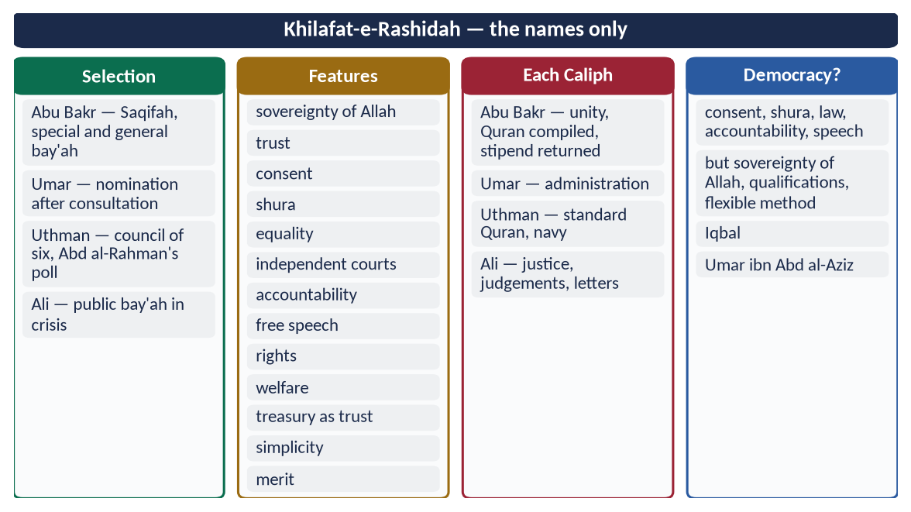
Figure 8 · At a glance — khilafat-e-Rashidah — the names only. The detail is in the sections above.

Chapter 6 · Hazrat Umar (RA): The Administrator and His Letters
The syllabus names 'the letters of Hazrat Umar (R.A) and Hazrat Ali (R.A) to different authorities'. They have never been asked, which makes them among the most likely questions of this topic.

6.1 Umar (RA) — the man and his rule
Umar ibn al-Khattab (RA) was Caliph for ten and a half years (13–23 AH / 634–644). He was the Prophet's ﷺ companion and father-in-law, and was given the title al-Faruq (the one who separates truth from falsehood). Under him the state grew from Arabia to Iraq, Persia, Syria, Palestine (Jerusalem, 638) and Egypt (641). He gave this vast state an administration.
✦ HADITH
لَوْ كَانَ بَعْدِي نَبِيٌّ لَكَانَ عُمَرَ بْنَ الْخَطَّابِ
“If there were to be a prophet after me, it would have been Umar ibn al-Khattab.” (Al-Tirmidhi)

6.2 Umar's administrative system
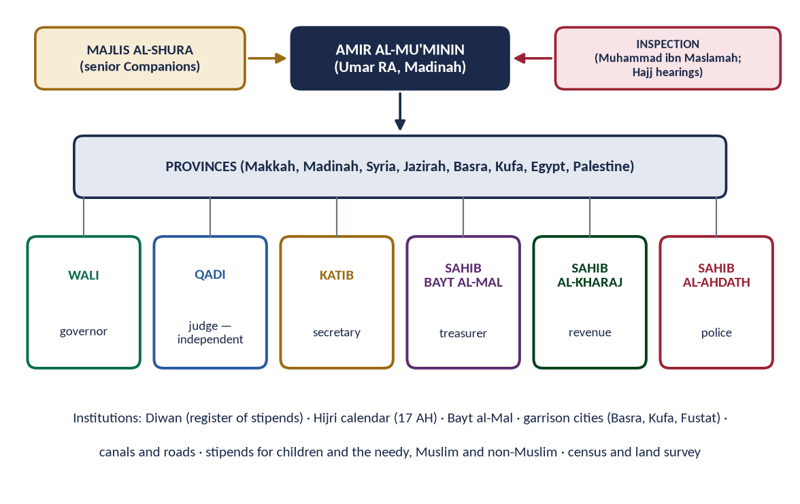
Figure 9 · Hazrat Umar's (RA) administrative structure and institutions.

(1) Provinces and their officers
The state was divided into provinces: Makkah, Madinah, Syria, Jazirah, Basra, Kufa, Egypt and Palestine (historians list these eight). Each had:
- a wali (governor);
- a katib (secretary);
- a sahib al-kharaj (revenue officer);
- a sahib al-ahdath (police chief);
- a sahib bayt al-mal (treasurer);
- a qadi (judge), independent of the governor.

(2) The Diwan
In about 20 AH / 641 (some historians say 15 AH) Umar set up the Diwan, a register of all who received stipends from the treasury, ranked by precedence in Islam. It was the first payroll and pension system of the Muslim state. Stipends were given even to new-born children. At first they began only at weaning; when Umar learnt that mothers were weaning early to get the stipend, he gave it from birth.

(3) The Bayt al-Mal
A central treasury in Madinah with branches in the provinces. Public money was kept separate from the Caliph's own.

(4) Judiciary
Judges were appointed separately from governors, paid well so that they would not be tempted, and instructed by letter (6.3).

(5) Police and prisons
The ahdath (police) kept order. Umar bought a house in Makkah to serve as a prison, the first in Islam.

(6) The Hijri calendar
In 17 AH / 638, after consultation, the Hijrah was fixed as the start of the Muslim calendar, on Ali's (RA) suggestion.

(7) Public works
- Garrison cities: Basra, Kufa and Fustat.
- Canals: the canal from the Nile to the Red Sea (Nahr Amir al-Mu'minin) carried grain to Arabia after the famine of 18 AH (the Year of Ramadah).
- Guest houses on the roads; the enlargement of the Prophet's Mosque.

(8) Land and revenue
- A survey of the land of Iraq.
- The conquered land kept as state land, with kharaj (land tax), after long Shura (Chapter 4).
- Jizyah (a tax on non-Muslim men in place of military service) excused for the poor, the old, women, children and monks.

(9) Welfare
- Stipends for the poor, widows and orphans.
- An allowance for the old Jewish beggar from the treasury, with the words: 'We took jizyah from him in his youth; it is not just to abandon him in his old age' (Abu Yusuf, Kitab al-Kharaj).
- Umar's night rounds. He found a widow boiling stones to calm her hungry children, and carried flour on his own back to her (reported in the histories).

(10) The Year of Ramadah (18 AH / 639)
In the great famine he gave up meat and butter until the people could eat them again, wrote to the governors of Egypt, Syria and Iraq for relief, and suspended the punishment for theft because hunger created doubt (shubhah). It is a classic of crisis management.

6.3 The letter to Abu Musa al-Ash'ari on judging
This is the most famous administrative letter in Islamic history. It was sent to Abu Musa al-Ash'ari (RA), judge and governor of Basra, and is recorded by Al-Daraqutni and Al-Bayhaqi. Ibn al-Qayyim wrote a long commentary on it in I'lam al-Muwaqqi'in.
✦ FROM THE SIRAH
أَمَّا بَعْدُ، فَإِنَّ الْقَضَاءَ فَرِيضَةٌ مُحْكَمَةٌ وَسُنَّةٌ مُتَّبَعَةٌ ... آسِ بَيْنَ النَّاسِ فِي وَجْهِكَ وَمَجْلِسِكَ وَعَدْلِكَ، حَتَّى لَا يَطْمَعَ شَرِيفٌ فِي حَيْفِكَ، وَلَا يَيْأَسَ ضَعِيفٌ مِنْ عَدْلِكَ. الْبَيِّنَةُ عَلَى مَنِ ادَّعَى، وَالْيَمِينُ عَلَى مَنْ أَنْكَرَ
“Judging is a firm obligation and a followed Sunnah … Treat people equally in your look, your sitting and your justice, so that the noble do not hope for your partiality, and the weak do not despair of your justice. The burden of proof is on the claimant, and the oath is on the one who denies.” (Al-Daraqutni; Al-Bayhaqi)
➜ The charter of the Islamic judiciary.

The principles of the letter
# | Principle | Meaning for today
1 | Understand the case before deciding | 'A right that is not carried out is of no use' — enforcement matters
2 | Equality in court | Equal treatment in look, seat and justice
3 | Burden of proof on the claimant; oath on the one who denies | The basic rule of evidence
4 | Settlement allowed | 'except one that makes the halal haram or the haram halal' — mediation (ADR)
5 | Time to produce evidence | Give a fixed period; if he fails, decide against him
6 | Review your own judgement | 'Do not let a judgement you made yesterday, then reconsidered, stop you from returning to the truth' — appeal and review
7 | Analogy (qiyas) | 'Understand what comes to you that is not in the Quran or the Sunnah; know the likenesses and compare matters'
8 | Witnesses are trustworthy | except those convicted of false testimony or punished in a hadd
9 | The judge's temperament | 'Beware of anger, anxiety, irritation and harming people in court'
10 | Sincerity | 'Whoever makes his intention pure, Allah suffices him in what is between him and people'

6.4 Umar's instructions to his governors

(1) The conditions of appointment
When he appointed a governor, Umar had the terms written down and witnessed. The governor was not to:
- ride a fine (Turkish) horse;
- wear fine clothes;
- eat fine white bread;
- keep a doorkeeper between himself and the people.
He was to keep his door open to the people's needs (reported by Al-Tabari and others).

(2) The purpose of a governor
✦ SCHOLARLY VIEW
Hazrat Umar (RA) · Instructions to his governors (Abu Yusuf, Kitab al-Kharaj; Al-Tabari)
I have not sent you as tyrants over the people, but as leaders of guidance, so that people may follow you. Give the Muslims their rights; do not beat them and humiliate them; do not praise them falsely and so mislead them; do not shut your doors against them, lest the strong among them devour the weak.
➜ The whole ethic of civil service in one instruction.

(3) The letter to Sa'd ibn Abi Waqqas (before Qadisiyyah, 636)
Umar told his commander to fear sins more than the enemy, because Muslims win by their obedience to Allah and not by numbers.

(4) The letter to Amr ibn al-As on the Copt
When the son of Amr ibn al-As, governor of Egypt, struck a Copt who had beaten him in a race, Umar called both to Madinah at Hajj. He let the Copt take his retaliation, and said to Amr:
✦ FROM THE SIRAH
مَتَى اسْتَعْبَدْتُمُ النَّاسَ وَقَدْ وَلَدَتْهُمْ أُمَّهَاتُهُمْ أَحْرَارًا؟
“Since when have you enslaved people, when their mothers bore them free?” (Ibn Abd al-Hakam, Futuh Misr)
➜ Equality of a non-Muslim citizen with the son of a governor — a famous report.

(5) The letter to Abu Musa on management
'The happiest ruler before Allah is the one whose people are happy through him, and the most wretched is the one whose people are wretched through him' (reported).

6.5 How Umar checked his officers
- Assets declared — a list of every governor's wealth at appointment. Unexplained increase was shared with the treasury (muqasamah); he did this with several governors, including Abu Hurayrah (RA) in Bahrain and Amr ibn al-As (RA) in Egypt.
- An inspector — Muhammad ibn Maslamah (RA) was sent to investigate complaints.
- The Hajj as a public hearing — governors came to Makkah each year, where any citizen could complain against them.
- Removal on complaint — he removed Sa'd ibn Abi Waqqas (RA) from Kufa after complaints, even though an inquiry found him innocent, to keep public trust. He removed Khalid ibn al-Walid (RA) from command so that people would not think victory came from a man rather than from Allah.
- His own family first — his sons Abdullah and Ubaydullah had traded with a loan from the treasury, given by Abu Musa. Umar made the deal a partnership, with half the profit to the treasury (Malik, Al-Muwatta', Book of Qirad).

6.6 Umar's sayings on governance
- 'Take account of yourselves before you are taken to account.'
- 'If a camel dies by the Euphrates, I fear that Allah will ask Umar about it' (reported).
- 'The strength of a ruler is not that he is harsh, and his softness is not that he is weak.'
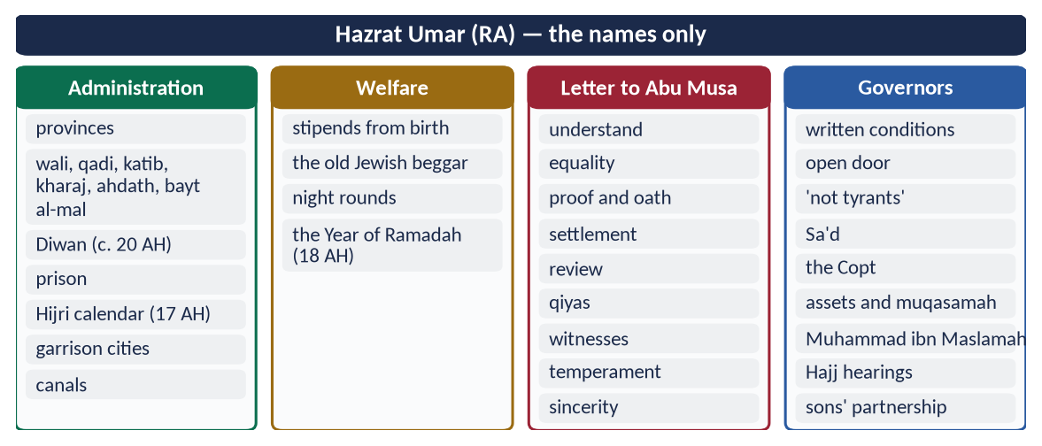
Figure 10 · At a glance — hazrat Umar (RA) — the names only. The detail is in the sections above.

Chapter 7 · Hazrat Ali (RA): Bravery, Juridical Wisdom and the Letter to Malik al-Ashtar
The base of 2020 Q3: 'Write a comprehensive note on the bravery and juridical wisdom of Hazrat Ali (R.A).'

7.1 His life in brief
Ali ibn Abi Talib (RA) was the Prophet's ﷺ cousin and son-in-law (husband of Fatimah (RA)), and father of Hasan and Husayn (RA). He was the first boy to accept Islam, and was raised in the Prophet's ﷺ household. He was the fourth Caliph (35–40 AH / 656–661) and was martyred in Kufa in Ramadan 40 AH / 661. His titles include Asadullah (the Lion of Allah) and Haydar-e-Karrar.

7.2 His bravery
- The night of the Hijrah (622): he slept in the Prophet's ﷺ bed while the Quraysh surrounded the house, then returned the trusts people had left with the Prophet ﷺ.
- Badr (2 AH): in the opening single combats he killed al-Walid ibn 'Utbah, and helped Hamzah and 'Ubaydah (RA).
- Uhud (3 AH): he stood firm around the Prophet ﷺ when many were scattered, and took many wounds.
- Khandaq (5 AH): he answered the challenge of 'Amr ibn 'Abd Wudd, the most feared warrior of Arabia, and killed him in single combat.
- Khaybar (7 AH):
✦ HADITH
لَأُعْطِيَنَّ الرَّايَةَ غَدًا رَجُلًا يُحِبُّ اللَّهَ وَرَسُولَهُ، وَيُحِبُّهُ اللَّهُ وَرَسُولُهُ، يَفْتَحُ اللَّهُ عَلَى يَدَيْهِ
“Tomorrow I will give the flag to a man who loves Allah and His Messenger, and whom Allah and His Messenger love; Allah will give victory at his hands.” (Al-Bukhari and Muslim)
➜ The flag went to Ali (RA), and the fortress of al-Qamus fell.

- Hunayn (8 AH): he was among those who stood firm when the army first fled.
- Tabuk (9 AH): he was left in charge of Madinah.
✦ HADITH
أَمَا تَرْضَى أَنْ تَكُونَ مِنِّي بِمَنْزِلَةِ هَارُونَ مِنْ مُوسَى، إِلَّا أَنَّهُ لَا نَبِيَّ بَعْدِي
“Are you not pleased to be to me as Harun was to Musa, except that there is no prophet after me?” (Al-Bukhari and Muslim)

- Moral courage: he fought only for principle. At the battle of the Trench, when an enemy spat at him, he held back his sword so that he would not kill out of personal anger (a famous report). As Caliph he forbade killing the wounded or pursuing those who fled.

7.3 His juridical wisdom

(1) The Prophet's ﷺ testimony and training
When the Prophet ﷺ sent him to Yemen as a judge, Ali said he was young and knew little of judging. The Prophet ﷺ struck his chest and prayed, 'O Allah, guide his heart and make his tongue firm' (Abu Dawud). He also taught him:
✦ HADITH
إِذَا تَقَاضَى إِلَيْكَ رَجُلَانِ فَلَا تَقْضِ لِلْأَوَّلِ حَتَّى تَسْمَعَ كَلَامَ الْآخَرِ، فَسَوْفَ تَدْرِي كَيْفَ تَقْضِي
“When two men bring a case to you, do not judge for the first until you have heard the other; then you will know how to judge.” (Al-Tirmidhi)
➜ Audi alteram partem — hear both sides — the first rule of natural justice.

(2) The testimony of the Companions
✦ FROM THE SIRAH
أَقْرَؤُنَا أُبَيٌّ، وَأَقْضَانَا عَلِيٌّ
“The best reciter among us is Ubayy, and the best judge among us is Ali.” (Al-Bukhari)
➜ Said by Hazrat Umar (RA).

Umar consulted him on hard cases. The saying 'had Ali not been there, Umar would have perished' is attributed to Umar in the histories.

(3) Famous judgements
Case | Ali's (RA) reasoning
The minimum period of pregnancy | A woman gave birth six months after marriage. It was pointed out (by Ali (RA); in some reports Ibn Abbas (RA)) that the Quran gives thirty months for pregnancy and weaning together (Al-Ahqaf 15) and two full years for weaning (Luqman 14). So pregnancy can be six months, and she was spared. It is an example of joining two verses.
The insane woman | A woman of unsound mind was brought for punishment. Ali reminded Umar of the hadith, 'The pen is lifted from three — the sleeper, the child and the insane' (Abu Dawud), and she was released. This is the principle of legal capacity.
The three men in Yemen | Three men claimed one child. Ali cast lots and made the winner pay two-thirds of the diyah to the other two; the Prophet ﷺ laughed at his ingenuity (Abu Dawud).
His own armour | As Caliph he found his armour with a Christian (in some reports, a Jew) and took the case to Qadi Shurayh. He could not produce acceptable witnesses (his son and his servant), and the judge ruled against the Caliph. The man, amazed, admitted the armour was Ali's and accepted Islam (reported by Abu Nu'aym and Al-Bayhaqi).
Equal distribution | He gave from the treasury equally, and refused his brother 'Aqil more than his share.
The Hijri calendar | He proposed dating the calendar from the Hijrah (17 AH).

(4) His knowledge and sayings
- 'Ask me before you lose me' — his confidence in his knowledge of the Quran.
- He guided Abu al-Aswad al-Du'ali to lay the foundations of Arabic grammar.
- 'Knowledge is better than wealth: knowledge guards you, while you guard wealth.'
- 'The value of every person is in what he does well.'

7.4 The letter to Malik al-Ashtar — the charter of governance
In 38 AH / 658, Ali (RA) appointed Malik al-Ashtar al-Nakha'i governor of Egypt and gave him a long letter of instruction. It is preserved in Nahj al-Balaghah (compiled by al-Sharif al-Radi, d. 1015). It is quoted worldwide as a classic of public administration; the UNDP's Arab Human Development Report (2002) cited Ali's sayings on good governance.
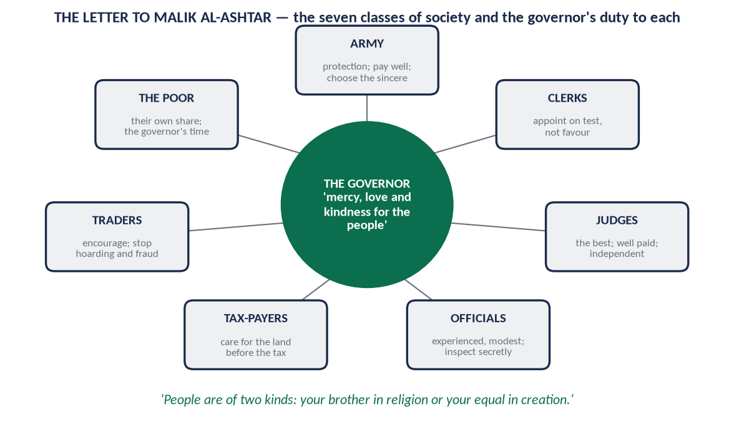
Figure 11 · The letter to Malik al-Ashtar: the classes of society and the governor's duty to each.
✦ FROM THE SIRAH
وَأَشْعِرْ قَلْبَكَ الرَّحْمَةَ لِلرَّعِيَّةِ، وَالْمَحَبَّةَ لَهُمْ، وَاللُّطْفَ بِهِمْ ... فَإِنَّهُمْ صِنْفَانِ: إِمَّا أَخٌ لَكَ فِي الدِّينِ، وَإِمَّا نَظِيرٌ لَكَ فِي الْخَلْقِ
“Fill your heart with mercy for the people, love for them and kindness towards them … for they are of two kinds: either your brother in religion or your equal in creation.” (Nahj al-Balaghah, Letter 53)
➜ The equal dignity of all citizens, Muslim and non-Muslim.

Its main instructions
- (a) Justice for the common people over the pleasure of the elite. The elite are the most burdensome in peace and the least helpful in hardship; the common people are the pillar of the state.
- (b) Forgiveness and humility. 'Do not say, "I am in command and must be obeyed", for that corrupts the heart.'
- (c) Consultation with the wise, and avoidance of the miser, the coward and the greedy as advisers.
- (d) The classes of society. The army, the clerks, the judges, the officials, the tax-payers, the traders and craftsmen, and the poor all depend on one another; each must be cared for.
- (e) Judges. Choose the best: one who is not irritated by litigants, does not persist in error, and is not greedy. Pay them well so that they need nothing from others, and give them a position no one can threaten.
- (f) Officials. Appoint them by test, not by favour. Choose the experienced and modest, pay them enough, and keep watch on them through trustworthy secret inspectors.
- (g) Revenue. Care for the cultivation of the land more than the collection of tax. Tax without development ruins the land and the people.
- (h) Traders. Encourage them, but prevent hoarding and unfair prices.
- (i) The poor, orphans and the disabled. Give them a share from the treasury and from the crops, and set aside time to meet them yourself, without guards.
- (j) Accessibility. 'Do not stay hidden from your people for long.'
- (k) Peace and treaties. Accept peace when the enemy offers it, and keep your treaties even at a loss.
- (l) Bloodshed. 'Beware of shedding blood unlawfully.'

7.5 Ali's other letters to officials
- To Uthman ibn Hunayf, governor of Basra: a rebuke for attending a lavish feast of the rich to which the poor were not invited.
- To tax-collectors: do not sell people's clothes, cattle or tools to collect tax, and do not beat anyone for a dirham.
- To a governor who misused funds: a warning that even if his own sons Hasan and Husayn had done the same, they would have found no favour with him.
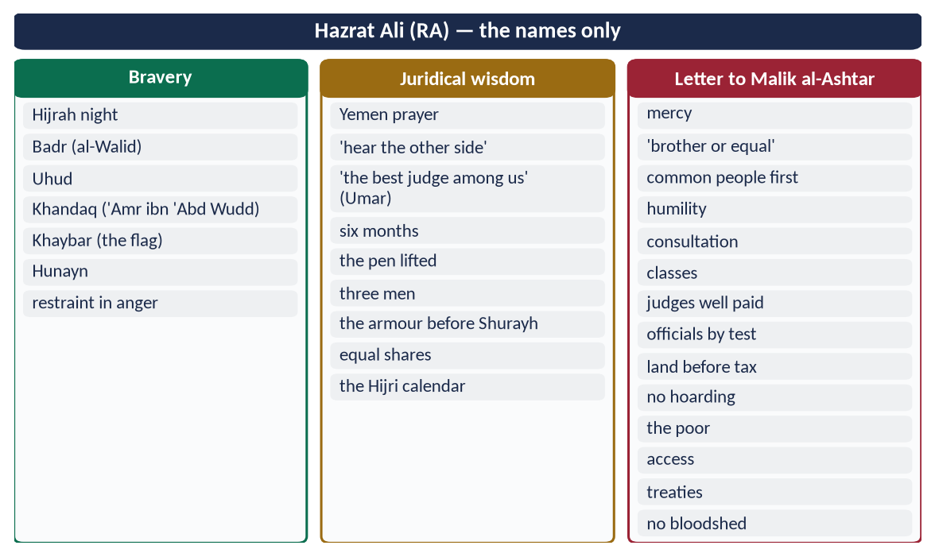
Figure 12 · At a glance — hazrat Ali (RA) — the names only. The detail is in the sections above.

Chapter 8 · The Responsibilities of Civil Servants
Asked twice: 2016 ('Explain the responsibilities of Civil Servants') and 2018 ('Highlight the responsibilities of civil servants in the light of Islamic teachings'). The candidate is applying to become one.

8.1 Who is a civil servant?
A civil servant is a permanent, paid official of the state who carries out government policy and serves the public — from the secretary of a ministry to the clerk at a counter. In Islam he is an 'amil (عَامِل) or muwazzaf, a trustee (amin) of public authority. He is not its owner.
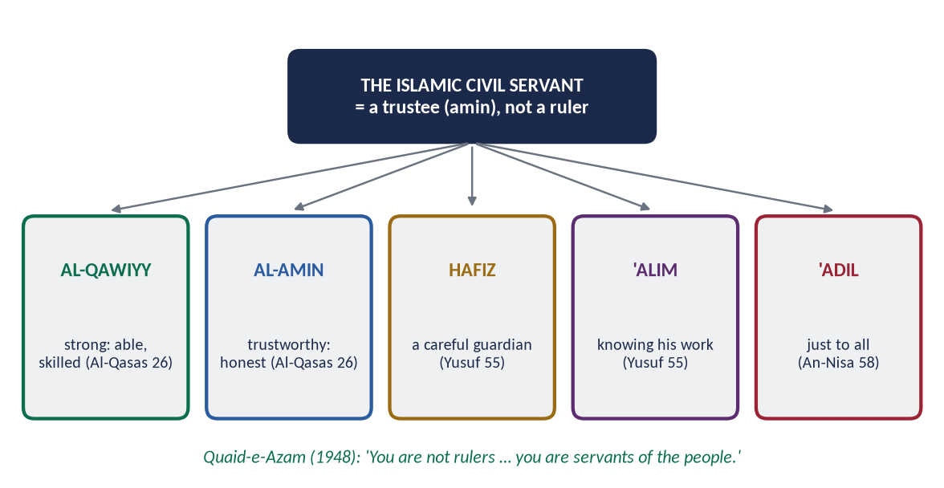
Figure 13 · The qualities of the Islamic civil servant from the Quran.

8.2 The qualities required — from the Quran
✦ QURAN
﴿قَالَتۡ إِحۡدَىٰهُمَا يَـٰٓأَبَتِ ٱسۡتَـٔۡجِرۡهُۖ إِنَّ خَيۡرَ مَنِ ٱسۡتَـٔۡجَرۡتَ ٱلۡقَوِيُّ ٱلۡأَمِينُ﴾
“One of the women said, "O my father, hire him. Indeed, the best one you can hire is the strong and the trustworthy.” (Al-Qasas, Quran)
➜ 'The best one you can hire is the strong (al-qawiyy) and the trustworthy (al-amin).'

✦ QURAN
﴿قَالَ ٱجۡعَلۡنِي عَلَىٰ خَزَآئِنِ ٱلۡأَرۡضِۖ إِنِّي حَفِيظٌ عَلِيمٞ﴾
“[Joseph] said, "Appoint me over the storehouses of the land. Indeed, I will be a knowing guardian.” (Yusuf, Quran)
➜ 'Put me in charge of the storehouses of the land; I am a knowing guardian (hafiz 'alim).'

✦ QURAN
﴿إِنَّ ٱللَّهَ يَأۡمُرُكُمۡ أَن تُؤَدُّواْ ٱلۡأَمَٰنَٰتِ إِلَىٰٓ أَهۡلِهَا وَإِذَا حَكَمۡتُم بَيۡنَ ٱلنَّاسِ أَن تَحۡكُمُواْ بِٱلۡعَدۡلِۚ …﴾
“Indeed, Allah commands you to render trusts to those entitled to them, and when you judge between people, to judge with justice.” (An-Nisa, Quran)
➜ Render trusts to those entitled to them; judge with justice.

8.3 The responsibilities of a civil servant in the light of Islam

(1) To treat office as a trust (amanah)
✦ QURAN
﴿يَـٰٓأَيُّهَا ٱلَّذِينَ ءَامَنُواْ لَا تَخُونُواْ ٱللَّهَ وَٱلرَّسُولَ وَتَخُونُوٓاْ أَمَٰنَٰتِكُمۡ وَأَنتُمۡ تَعۡلَمُونَ﴾
“O you who have believed, do not betray Allah and the Messenger or betray your trusts while you know [the consequence].” (Al-Anfal, Quran)
➜ O you who believe, do not betray Allah and the Messenger, and do not betray your trusts knowingly.

✦ HADITH
آيَةُ الْمُنَافِقِ ثَلَاثٌ: إِذَا حَدَّثَ كَذَبَ، وَإِذَا وَعَدَ أَخْلَفَ، وَإِذَا اؤْتُمِنَ خَانَ
“The signs of a hypocrite are three: when he speaks he lies, when he promises he breaks it, and when he is trusted he betrays.” (Al-Bukhari and Muslim)
➜ Misuse of office is a sign of hypocrisy.

(2) Honesty — no embezzlement (ghulul)
✦ QURAN
﴿وَمَا كَانَ لِنَبِيٍّ أَن يَغُلَّۚ وَمَن يَغۡلُلۡ يَأۡتِ بِمَا غَلَّ يَوۡمَ ٱلۡقِيَٰمَةِۚ ثُمَّ تُوَفَّىٰ كُلُّ نَفۡسٖ مَّا كَسَبَتۡ وَهُمۡ لَا يُظۡلَمُونَ﴾
“It is not [attributable] to any prophet that he would act unfaithfully [in regard to war booty]. And whoever betrays, [taking unlawfully], will come with what he took on the Day of Resurrection. Then will every soul be [fully] compensated for what it earned, and they will not be wronged.” (Aal-e-Imran, Quran)
➜ Whoever betrays will bring what he took on the Day of Resurrection.

✦ HADITH
مَنِ اسْتَعْمَلْنَاهُ مِنْكُمْ عَلَى عَمَلٍ، فَكَتَمَنَا مِخْيَطًا فَمَا فَوْقَهُ، كَانَ غُلُولًا يَأْتِي بِهِ يَوْمَ الْقِيَامَةِ
“Whoever of you we appoint to a post and he hides from us a needle or more, that is embezzlement he will bring on the Day of Resurrection.” (Muslim)
➜ Not even a needle of public property.

(3) No bribes and no 'gifts' of office
✦ HADITH
لَعَنَ رَسُولُ اللَّهِ ﷺ الرَّاشِيَ وَالْمُرْتَشِيَ
“The Messenger of Allah ﷺ cursed the one who gives a bribe and the one who takes it.” (Abu Dawud and Al-Tirmidhi)

✦ HADITH
فَهَلَّا جَلَسَ فِي بَيْتِ أَبِيهِ أَوْ بَيْتِ أُمِّهِ فَيَنْظُرَ يُهْدَى لَهُ أَمْ لَا
“Why did he not sit in the house of his father or his mother and see whether gifts would come to him?” (Al-Bukhari)
➜ Said about Ibn al-Lutbiyyah, the Zakat collector who said, 'This is for you, and this was given to me as a gift.' Gifts that come because of the office belong to the state.

(4) Merit and fairness in appointments — no nepotism
✦ HADITH
إِنَّا وَاللَّهِ لَا نُوَلِّي عَلَى هَذَا الْعَمَلِ أَحَدًا سَأَلَهُ، وَلَا أَحَدًا حَرَصَ عَلَيْهِ
“By Allah, we do not appoint to this work anyone who asks for it, or anyone who is eager for it.” (Al-Bukhari and Muslim)
➜ Office is not a prize to be lobbied for (sifarish).

✦ HADITH
إِذَا وُسِّدَ الْأَمْرُ إِلَى غَيْرِ أَهْلِهِ فَانْتَظِرِ السَّاعَةَ
“When authority is given to those not fit for it, then wait for the Hour.” (Al-Bukhari)

(5) Justice and equal treatment of all citizens
✦ QURAN
﴿… وَلَا يَجۡرِمَنَّكُمۡ شَنَـَٔانُ قَوۡمٍ عَلَىٰٓ أَلَّا تَعۡدِلُواْۚ ٱعۡدِلُواْ هُوَ أَقۡرَبُ لِلتَّقۡوَىٰۖ …﴾
“Do not let the hatred of a people lead you to be unjust. Be just; that is nearer to righteousness.” (Al-Ma'idah, Quran)
➜ Do not let the hatred of a people lead you to injustice. Be just.

Ali (RA) to Malik al-Ashtar: citizens are 'your brother in religion or your equal in creation' — no discrimination by religion, sect, language, province or party.

(6) Accessibility and service
✦ HADITH
مَنْ وَلَّاهُ اللَّهُ عَزَّ وَجَلَّ شَيْئًا مِنْ أَمْرِ الْمُسْلِمِينَ فَاحْتَجَبَ دُونَ حَاجَتِهِمْ ... احْتَجَبَ اللَّهُ عَنْهُ دُونَ حَاجَتِهِ
“Whoever is put in charge of the Muslims' affairs and shuts himself away from their needs, Allah will shut Himself away from his needs.” (Abu Dawud)
➜ Umar's rule: no doorkeeper between the governor and the people.

(7) Gentleness and easing people's work
✦ HADITH
اللَّهُمَّ مَنْ وَلِيَ مِنْ أَمْرِ أُمَّتِي شَيْئًا فَشَقَّ عَلَيْهِمْ فَاشْقُقْ عَلَيْهِ
“O Allah, whoever takes charge of any affair of my Ummah and makes it hard for them, make it hard for him.” (Muslim)
➜ Red tape, delays and needless files are a Prophetic curse on officials.

(8) Excellence, diligence and punctuality (ihsan and itqan)
✦ HADITH
إِنَّ اللَّهَ يُحِبُّ إِذَا عَمِلَ أَحَدُكُمْ عَمَلًا أَنْ يُتْقِنَهُ
“Allah loves that when one of you does a job, he does it with perfection.” (Al-Bayhaqi, Shu'ab al-Iman)

Salary for time not worked is not lawful. The Hanafi jurists call an employee paid by time an ajir khass, who owes his working hours to the employer.

(9) Obedience to lawful orders — and refusal of unlawful ones
✦ HADITH
لَا طَاعَةَ فِي مَعْصِيَةٍ، إِنَّمَا الطَّاعَةُ فِي الْمَعْرُوفِ
“There is no obedience in disobedience (to Allah); obedience is only in what is right.” (Al-Bukhari and Muslim)
➜ A civil servant must obey lawful orders and refuse illegal ones — the Quaid's advice below.

(10) Keeping secrets and records
Confidential official information is an amanah. The Prophet's ﷺ secretaries (Zayd ibn Thabit) and Umar's diwan kept accurate records. Forgery and false entries are lying and betrayal.

(11) Simplicity and avoiding conflict of interest
No private business that uses the office. Umar made his own sons' profit a partnership with the treasury (Al-Muwatta'). No display of luxury: Umar's written conditions forbade fine horses, fine clothes and doorkeepers.

(12) Political neutrality
The civil servant serves the state and the people, whichever government is in power. He owes loyalty to the law and the Constitution, not to a party.

(13) Accountability — to Allah, to the law and to the people
✦ HADITH
كُلُّكُمْ رَاعٍ وَكُلُّكُمْ مَسْئُولٌ عَنْ رَعِيَّتِهِ
“Each of you is a shepherd and each is responsible for his flock.” (Al-Bukhari and Muslim)

8.4 The Quaid-e-Azam's advice to civil servants
✦ SCHOLARLY VIEW
Quaid-e-Azam Muhammad Ali Jinnah · Address to civil officers, Peshawar, 14 April 1948
“You should not be influenced by any political pressure, by any political party or individual politician. If you want to raise the prestige and greatness of Pakistan, you must not fall a victim to any pressure, but do your duty as servants of the people and the State, fearlessly and honestly.”
➜ Neutrality and courage.

✦ SCHOLARLY VIEW
Quaid-e-Azam Muhammad Ali Jinnah · Address to government officers, Chittagong, 25 March 1948
You do not belong to the ruling class; you belong to the servants. Make the people feel that you are their servants and friends.
➜ Service, not rule.

8.5 The law in Pakistan
Law / rule | What it requires
Civil Servants Act (1973) | Terms of service; posts held 'during the pleasure of the President'
Government Servants (Conduct) Rules (1964) | No gifts beyond set limits; declaration of assets; no private trade; no political activity
Efficiency and Discipline Rules (2020) | Penalties for inefficiency, misconduct and corruption
Articles 240–242 of the Constitution | Services of Pakistan; Public Service Commissions
Article 5 | Loyalty to the State and obedience to the Constitution and law

8.6 The problems today — and the Islamic cure
Problem | Islamic teaching that cures it
Corruption and bribery | 'Cursed are the briber and the bribe-taker'; the needle hadith
Sifarish and nepotism | 'We do not appoint anyone who asks for it'; merit (Al-Qasas 26)
Delay, red tape, rudeness | 'Whoever makes it hard for them …'; the open door
Political pressure | 'No obedience in disobedience'; the Quaid's advice
Colonial 'ruler' mindset | 'You are servants, not rulers'; Ali's 'brother or equal'
Idleness, absenteeism | Itqan; the ajir khass owes his hours
Misuse of state vehicles, offices | Ghulul; Umar's conditions of austerity

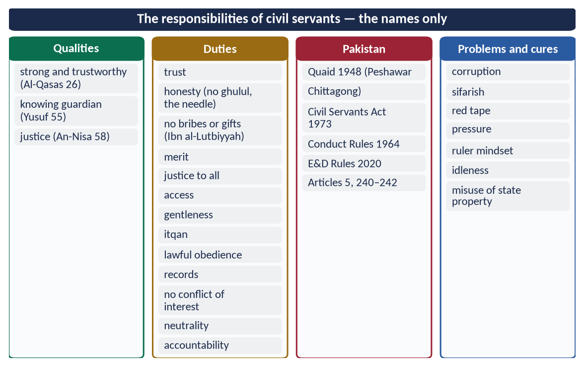
Figure 14 · At a glance — the responsibilities of civil servants — the names only. The detail is in the sections above.

Chapter 9 · Accountability and Hisbah in Islam
The syllabus line 'System of Accountability (Hisbah) in Islam'. It was asked in 2021 (accountability of rulers), 2024 (accountability in Pakistan in the light of the Prophet's ﷺ teachings) and 2026 (the concept of accountability and the Rashidun's highest standard).

9.1 The concept of accountability
Accountability (muhasabah, مُحَاسَبَة) means that every holder of power must answer for how he used it: to Allah in the Hereafter, and to the law and the people in this world. In Islam it begins with belief. The Day of Judgement is the Day of Reckoning (Yawm al-Hisab).
✦ QURAN
﴿فَمَن يَعۡمَلۡ مِثۡقَالَ ذَرَّةٍ خَيۡرٗا يَرَهُۥ ۝ وَمَن يَعۡمَلۡ مِثۡقَالَ ذَرَّةٖ شَرّٗا يَرَهُۥ﴾
“So whoever does an atom's weight of good will see it. And whoever does an atom's weight of evil will see it.” (Az-Zalzalah, Quran)
➜ Whoever does an atom's weight of good will see it, and whoever does an atom's weight of evil will see it.

✦ QURAN
﴿وَلَا تَقۡفُ مَا لَيۡسَ لَكَ بِهِۦ عِلۡمٌۚ إِنَّ ٱلسَّمۡعَ وَٱلۡبَصَرَ وَٱلۡفُؤَادَ كُلُّ أُوْلَـٰٓئِكَ كَانَ عَنۡهُ مَسۡـُٔولٗا﴾
“And do not pursue that of which you have no knowledge. Indeed, the hearing, the sight and the heart - about all those [one] will be questioned.” (Al-Isra, Quran)
➜ The hearing, the sight and the heart — all of these will be questioned.

✦ QURAN
﴿ثُمَّ لَتُسۡـَٔلُنَّ يَوۡمَئِذٍ عَنِ ٱلنَّعِيمِ﴾
“Then you will surely be asked that Day about pleasure.” (At-Takathur, Quran)
➜ Then you will surely be asked on that Day about the pleasures.

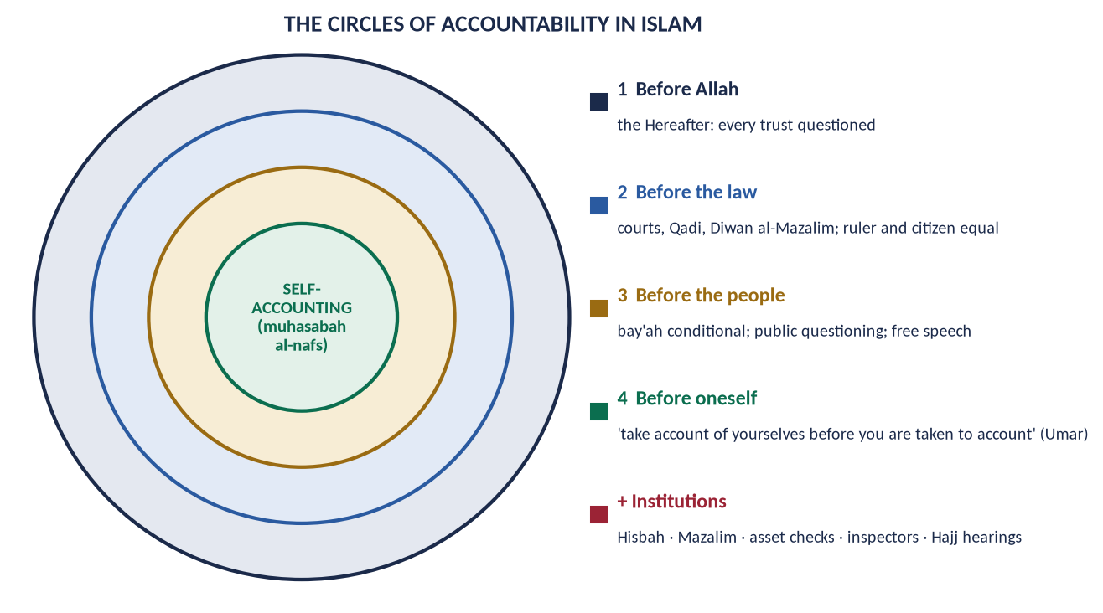
Figure 15 · The circles of accountability in Islam.

9.2 The kinds and levels of accountability

(1) Before Allah
✦ QURAN
﴿فَوَرَبِّكَ لَنَسۡـَٔلَنَّهُمۡ أَجۡمَعِينَ ۝ عَمَّا كَانُواْ يَعۡمَلُونَ﴾
“So by your Lord, We will surely question them all. About what they used to do.” (Al-Hijr, Quran)
➜ By your Lord, We will surely question them all about what they used to do.

✦ HADITH
لَا تَزُولُ قَدَمَا عَبْدٍ يَوْمَ الْقِيَامَةِ حَتَّى يُسْأَلَ عَنْ عُمُرِهِ فِيمَا أَفْنَاهُ، وَعَنْ عِلْمِهِ فِيمَ فَعَلَ، وَعَنْ مَالِهِ مِنْ أَيْنَ اكْتَسَبَهُ وَفِيمَ أَنْفَقَهُ، وَعَنْ جِسْمِهِ فِيمَ أَبْلَاهُ
“The feet of a servant will not move on the Day of Resurrection until he is asked about his life and how he spent it, his knowledge and what he did with it, his wealth — where he earned it and how he spent it, and his body and how he used it.” (Al-Tirmidhi)
➜ The Quranic 'money trail': where from, and where to?

(2) Self-accountability
'Take account of yourselves before you are taken to account, and weigh your deeds before they are weighed' — Hazrat Umar (RA) (Al-Tirmidhi reports it from him). It is the inner audit that makes all outer audits work.

(3) Before the law — no immunity
- The Fatimah hadith: the law is the same for the noble and the weak (Al-Bukhari and Muslim).
- The Prophet ﷺ offered himself for retaliation. At Badr, when he poked Sawad ibn Ghaziyyah with an arrow while straightening the ranks, Sawad asked for retaliation; the Prophet ﷺ bared his stomach, and Sawad kissed it (Ibn Ishaq).
- The Caliphs in court — Umar before Zayd ibn Thabit; Ali before Shurayh.

(4) Before the people
✦ FROM THE SIRAH
فَإِنْ أَحْسَنْتُ فَأَعِينُونِي، وَإِنْ أَسَأْتُ فَقَوِّمُونِي
“If I do well, help me; if I do wrong, set me right.” (Ibn Hisham)
➜ Abu Bakr (RA): the people's right to correct the ruler.

✦ HADITH
أَفْضَلُ الْجِهَادِ كَلِمَةُ عَدْلٍ عِنْدَ سُلْطَانٍ جَائِرٍ
“The best jihad is a word of justice before a tyrant ruler.” (Abu Dawud and Al-Tirmidhi)

✦ HADITH
الدِّينُ النَّصِيحَةُ ... لِلَّهِ وَلِكِتَابِهِ وَلِرَسُولِهِ وَلِأَئِمَّةِ الْمُسْلِمِينَ وَعَامَّتِهِمْ
“Religion is sincere advice … to Allah, His Book, His Messenger, the leaders of the Muslims and their common people.” (Muslim)

(5) Through institutions
Hisbah, the Mazalim court, the Qadi, inspectors, asset checks and the Shura (9.4–9.6).

9.3 The principles of the accountability of rulers (2021)
# | Principle | Evidence
1 | Power is a trust, and the trustee answers for it | An-Nisa 58; 'it is a trust … disgrace and regret' (Muslim)
2 | The ruler is under the law | 'If Fatimah stole …'; Umar and Ali in court
3 | Obedience is conditional | An-Nisa 59; 'no obedience in disobedience'; Abu Bakr's 'if I disobey, no obedience'
4 | The people have the right to question and correct | 'Set me right'; the word of justice; nasihah
5 | Transparency of wealth | 'Where did you earn it?' (Al-Tirmidhi); Umar's asset register
6 | No private gain from office | Ibn al-Lutbiyyah; the needle hadith; Abu Bakr's stipend returned
7 | Equality — no immunity for relatives | Umar's sons; Ali's refusal to 'Aqil
8 | Consultation checks the ruler | Ash-Shura 38; Aal-e-Imran 159
9 | Independent judges | Umar's letter to Abu Musa; the Qadi separate from the governor
10 | Removal of the unfit | Umar removed governors on complaint; lawful and peaceful means, never armed revolt (Chapter 7 of Topic 7)

9.4 Hisbah — the institution

(1) Meaning and basis
Hisbah (حِسْبَة) is the duty and the institution of enjoining good and forbidding wrong in public life. The muhtasib is its officer.
✦ QURAN
﴿وَلۡتَكُن مِّنكُمۡ أُمَّةٞ يَدۡعُونَ إِلَى ٱلۡخَيۡرِ وَيَأۡمُرُونَ بِٱلۡمَعۡرُوفِ وَيَنۡهَوۡنَ عَنِ ٱلۡمُنكَرِۚ وَأُوْلَـٰٓئِكَ هُمُ ٱلۡمُفۡلِحُونَ﴾
“And let there be [arising] from you a nation inviting to [all that is] good, enjoining what is right and forbidding what is wrong, and those will be the successful.” (Aal-e-Imran, Quran)
➜ Let there be among you a group inviting to good, enjoining right and forbidding wrong — those are the successful.

✦ QURAN
﴿وَٱلۡمُؤۡمِنُونَ وَٱلۡمُؤۡمِنَٰتُ بَعۡضُهُمۡ أَوۡلِيَآءُ بَعۡضٖۚ يَأۡمُرُونَ بِٱلۡمَعۡرُوفِ وَيَنۡهَوۡنَ عَنِ ٱلۡمُنكَرِ …﴾
“The believing men and believing women are allies of one another; they enjoin what is right and forbid what is wrong.” (At-Tawbah, Quran)
➜ The believing men and believing women are allies of one another; they enjoin right and forbid wrong.

✦ HADITH
مَنْ رَأَى مِنْكُمْ مُنْكَرًا فَلْيُغَيِّرْهُ بِيَدِهِ، فَإِنْ لَمْ يَسْتَطِعْ فَبِلِسَانِهِ، فَإِنْ لَمْ يَسْتَطِعْ فَبِقَلْبِهِ، وَذَلِكَ أَضْعَفُ الْإِيمَانِ
“Whoever of you sees a wrong, let him change it with his hand; if he cannot, then with his tongue; if he cannot, then with his heart — and that is the weakest faith.” (Muslim)
➜ 'With the hand' belongs to lawful authority, the muhtasib and the state. The citizen's part is the tongue: complaint and advice.

(2) The Prophet ﷺ as the first muhtasib
✦ HADITH
مَنْ غَشَّ فَلَيْسَ مِنِّي
“Whoever cheats is not of me.” (Muslim)
➜ He put his hand into a heap of grain, found it wet underneath, and said this. It is the first market inspection in Islam.

He appointed Sa'id ibn Sa'id ibn al-'As over the market of Makkah after its conquest (reported by Ibn Sa'd and Ibn Abd al-Barr).

(3) Under the Caliphs
Umar (RA) inspected markets himself, checked weights, and stopped the sale of adulterated milk. A woman, al-Shifa' bint Abdullah (RA), is reported to have been given duties in the market of Madinah.

(4) The developed institution
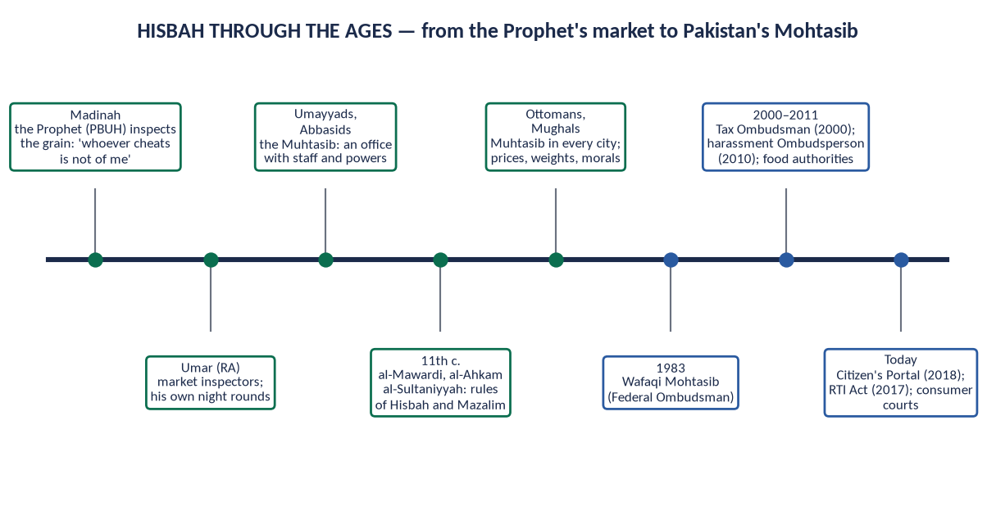
Figure 16 · Hisbah through the ages, from the Prophet's market to Pakistan's Mohtasib.
Under the Umayyads and Abbasids the muhtasib became a regular officer with staff. Al-Mawardi (Al-Ahkam al-Sultaniyyah) and later jurists wrote its rules.

(5) The duties of the muhtasib
Area | Duties
Market | Weights and measures; quality; fraud; hoarding; fair dealing
Public health | Cleanliness of streets, food shops, water; slaughter houses
Public order | Obstruction of roads; unsafe buildings; cruelty to animals
Public morals | Open indecency; neglect of public prayers (with wisdom, not force)
Professions | Checking doctors, teachers and craftsmen for competence
Officials | Reporting the misconduct of officials to higher authority

(6) The conditions of the muhtasib
He must be a just, knowledgeable, gentle and firm Muslim. He acts only on open wrongs; he may not spy into homes.
✦ QURAN
﴿… ٱجۡتَنِبُواْ كَثِيرٗا مِّنَ ٱلظَّنِّ إِنَّ بَعۡضَ ٱلظَّنِّ إِثۡمٞۖ وَلَا تَجَسَّسُواْ وَلَا يَغۡتَب بَّعۡضُكُم بَعۡضًاۚ …﴾
“Avoid much suspicion; indeed, some suspicion is sin. And do not spy, and do not backbite one another.” (Al-Hujurat, Quran)
➜ 'Do not spy, and do not backbite one another.'

9.5 Diwan al-Mazalim — the court of grievances
The Mazalim court heard complaints against officials and the powerful, which ordinary judges could not enforce. Its roots are in the Prophet's ﷺ hearing of complaints and Umar's Hajj hearings. Abd al-Malik set special days for it, and Umar ibn Abd al-Aziz revived it strongly. It is the ancestor of the ombudsman and administrative courts.

9.6 Hisbah and Mazalim today — the Mohtasib in Pakistan
Institution | Function
Wafaqi Mohtasib (Federal Ombudsman), 1983 | Complaints of maladministration against federal agencies
Provincial Ombudsmen | The same at provincial level
Federal Tax Ombudsman (2000) | Complaints against tax officials
Banking Mohtasib; Insurance Ombudsman | Financial services
Federal Ombudsperson for Protection against Harassment (2010 Act) | Harassment at the workplace
Food authorities; price magistrates; consumer courts | The market duties of the old muhtasib
Pakistan Citizen's Portal (2018) | Online complaints to all government departments

9.7 The highest standard — the Rashidun in practice (2026)
- Abu Bakr (RA): his stipend was fixed by the Companions at a modest level, and before his death he returned it from his own property. Umar said, 'He has made it hard for those after him.'
- Umar (RA): assets of governors listed; muqasamah of unexplained wealth; Muhammad ibn Maslamah as inspector; the Hajj hearings; his sons' profit shared with the treasury (Al-Muwatta'); 'Fear Allah!' accepted from a man in public.
- Uthman (RA): answered his critics publicly in the Mosque and sent inspectors to the provinces (35 AH).
- Ali (RA): lost his own case before Qadi Shurayh; refused his brother 'Aqil any extra from the treasury; warned governors that no relation would save them.
Why the highest standard? Accountability began at the top. The Caliph was checked first, then his family, then his governors. It rested on taqwa, so it did not need to be forced, and it was public.
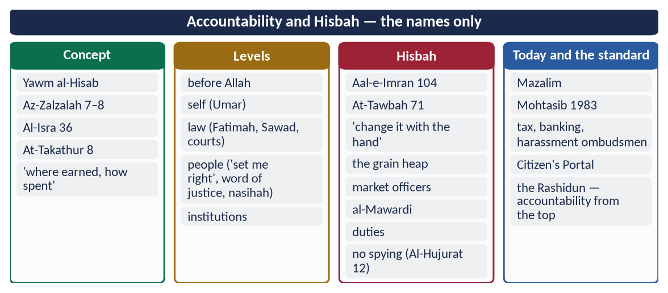
Figure 17 · At a glance — accountability and Hisbah — the names only. The detail is in the sections above.

Chapter 10 · Accountability and Political Reform in Pakistan
The base of 2024 ('How can the system of accountability in Pakistan be idealized in the teachings of the Holy Prophet ﷺ?') and 2019 ('Give suggestions to reform Pakistani politics keeping in view the different aspects of the political system of Islam').

10.1 The accountability system of Pakistan
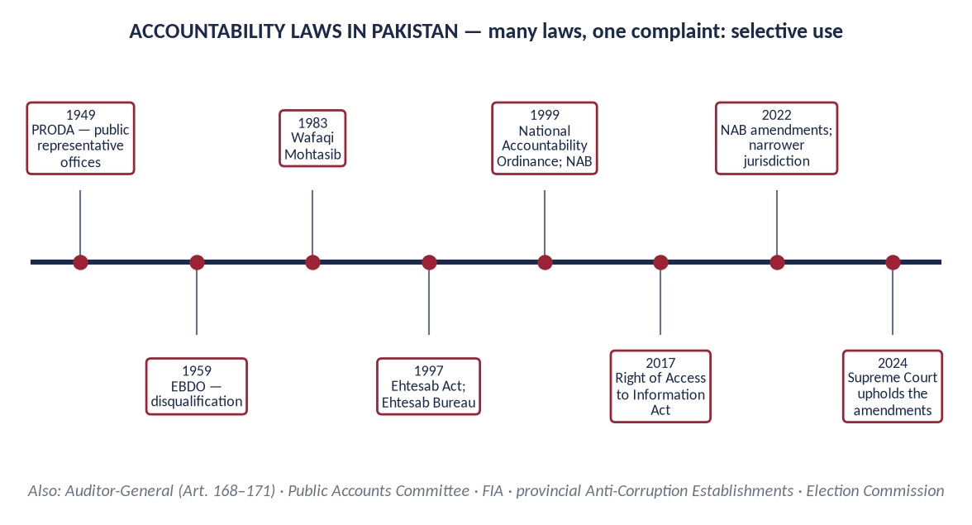
Figure 18 · Accountability laws in Pakistan since 1949.
Institution | Role
National Accountability Bureau (NAB) | Set up under the National Accountability Ordinance (1999) to investigate and prosecute corruption; plea bargain and voluntary return
Accountability courts | Special courts for NAB cases
Federal Investigation Agency (FIA) | Corruption by federal employees; money laundering
Anti-Corruption Establishments | Provincial corruption cases
Auditor-General of Pakistan (Articles 168–171) | Audit of all public accounts, reported to Parliament
Public Accounts Committee | Parliament's committee that examines the audit reports
Election Commission (Articles 218–219) | Assets declarations of members; election disputes
Wafaqi and provincial Mohtasibs | Maladministration
Right of Access to Information Act (2017) | Citizens' right to see public records
Superior courts | Judicial review; suo motu (Article 184(3))

10.2 The weaknesses
- (a) Selective accountability. Critics of every period say accountability falls on opponents and spares allies: 'victimisation, not accountability'.
- (b) Political engineering. From PRODA (1949) and EBDO (1959) onwards, accountability laws were used to disqualify politicians.
- (c) Low conviction rates and long trials. Cases run for years, and many end in acquittal or plea bargains.
- (d) Frequent changes in law. The 2022 amendments to the NAB law narrowed its jurisdiction (cases below Rs 500 million excluded). The Supreme Court struck down parts of them in 2023, then upheld them in 2024 on appeal. Uncertainty weakens both deterrence and fairness.
- (e) The 'fear factor'. Honest officers avoid decisions for fear of cases, so files are delayed.
- (f) No accountability for some institutions — the complaint that some groups stand above the law.
- (g) Weak prevention. Most effort goes into punishment after the fact, not into transparency, e-governance and simpler rules that stop corruption before it happens.
- (h) Low public trust. Transparency International's Corruption Perceptions Index 2024 placed Pakistan 135th of 180.

10.3 How the system can be idealised in the teachings of the Holy Prophet ﷺ (2024)

(1) Equality — accountability for all, starting at the top
✦ HADITH
وَايْمُ اللَّهِ لَوْ أَنَّ فَاطِمَةَ بِنْتَ مُحَمَّدٍ سَرَقَتْ لَقَطَعْتُ يَدَهَا
“By Allah, if Fatimah the daughter of Muhammad stole, I would cut off her hand.” (Al-Bukhari and Muslim)

Reform: one law for politicians, officials, judges, generals and businessmen; no exemptions; the accountability body independent of the government of the day.

(2) Justice, not revenge
✦ QURAN
﴿… وَلَا يَجۡرِمَنَّكُمۡ شَنَـَٔانُ قَوۡمٍ عَلَىٰٓ أَلَّا تَعۡدِلُواْۚ ٱعۡدِلُواْ هُوَ أَقۡرَبُ لِلتَّقۡوَىٰۖ …﴾
“Do not let the hatred of a people lead you to be unjust. Be just; that is nearer to righteousness.” (Al-Ma'idah, Quran)
➜ Do not let the hatred of a people lead you to injustice. Be just.

Reform: an accountability chief appointed by consensus of government and opposition; no arrest before evidence; time limits for investigation.

(3) Due process — hear both sides
The Prophet's ﷺ instruction to Ali: 'Do not judge for the first until you hear the other' (Al-Tirmidhi). 'The burden of proof is on the claimant' (Umar's letter).
Reform: fair trial (Article 10-A); no media trials; speedy courts with fixed time limits.

(4) The money trail — 'where from, where to?'
✦ HADITH
وَعَنْ مَالِهِ مِنْ أَيْنَ اكْتَسَبَهُ وَفِيمَ أَنْفَقَهُ
“… and about his wealth: where he earned it and how he spent it.” (Al-Tirmidhi)

Reform: yearly, public, verified asset declarations by all office-holders and senior officials, as Umar kept a register of his governors' wealth.

(5) No gifts of office — Ibn al-Lutbiyyah
'Why did he not sit in his father's house and see whether gifts would come to him?' (Al-Bukhari).
Reform: strict rules on gifts. The Toshakhana (the store of state gifts) should keep official gifts for the state and publish records of them.

(6) Prevention through transparency
✦ QURAN
﴿يَـٰٓأَيُّهَا ٱلَّذِينَ ءَامَنُوٓاْ إِذَا تَدَايَنتُم بِدَيۡنٍ إِلَىٰٓ أَجَلٖ مُّسَمّٗى فَٱكۡتُبُوهُۚ …﴾
“O you who believe, when you contract a debt for a fixed term, write it down.” (Al-Baqarah, Quran)
➜ When you contract a debt for a fixed term, write it down.

Reform: e-procurement, digital payments, open budgets, the Right to Information Act enforced — transparency that removes the chance for corruption.

(7) Merit in appointments
'We do not appoint anyone who asks for it' (Al-Bukhari and Muslim); Al-Qasas 26.
Reform: appointments through Public Service Commissions; an end to sifarish and political postings.

(8) Fair pay and simple living
Ali's advice to pay officials enough that they do not need bribes; Abu Bakr's modest stipend.
Reform: a living wage for officials, with an end to luxury perks (vehicles, plots, protocol).

(9) Hisbah — the people's voice
'Change it with the tongue' (Muslim); 'the best jihad is a word of justice' (Abu Dawud).
Reform: strong Mohtasib offices, whistle-blower protection, a free and responsible press, and the Citizen's Portal.

(10) Taqwa — the inner auditor
✦ QURAN
﴿… وَهُوَ مَعَكُمۡ أَيۡنَ مَا كُنتُمۡۚ وَٱللَّهُ بِمَا تَعۡمَلُونَ بَصِيرٞ﴾
“And He is with you wherever you are; and Allah sees what you do.” (Al-Hadid, Quran)
➜ 'He is with you wherever you are, and Allah sees what you do.'

Reform: ethics training for officials, oaths taken seriously, and character education in schools. No law can succeed where there is no fear of Allah.

10.4 Reforming Pakistani politics in the light of the Islamic political system (2019)

(1) The problems
Problem | Islamic principle violated
Dynastic politics; hereditary party leadership | The Rashidun refused heredity; merit (An-Nisa 58)
Money in elections; buying votes and 'electables' | Bribery cursed; office not for those who seek it
Floor-crossing and horse-trading | Keeping covenants (Al-Ma'idah 1; Al-Isra 34)
No democracy inside parties | Shura (Ash-Shura 38)
Hate speech, abuse, polarisation | 'Do not mock … do not insult' (Al-Hujurat 11)
Refusing election results; street chaos | Obedience within law; 'no harm' (Ibn Majah)
Corruption and misuse of office | Ghulul; accountability
Civil–military imbalance; weak institutions | Rule of law; every institution under the Constitution
Neglect of local government | Umar's provinces with real powers

(2) The suggestions
- (a) Merit and character in candidates. Enforce Articles 62–63 (the qualifications of members) fairly and through courts, not politics. Parties should nominate honest, qualified people, not only 'electables'.
- (b) Shura inside parties. Regular, genuine intra-party elections, as the law requires. Leadership chosen by consultation, not inheritance.
- (c) Clean elections. An independent Election Commission (Articles 218–219); limits on campaign spending; transparent party funding; electoral technology accepted by all parties.
- (d) Accountability without victimisation (10.3).
- (e) Tolerance and a code of conduct. Opponents are fellow citizens. The Prophet ﷺ tolerated even Abdullah ibn Ubayy. A charter of political conduct agreed by all parties, like the Charter of Democracy (2006), could bind them.
- (f) Rule of law and supremacy of the Constitution. Every institution within its own sphere (Articles 5 and 6).
- (g) Empowered local government (Article 140A). Power and funds should reach districts, as Umar's governors ran their provinces.
- (h) Welfare politics instead of patronage. Policies for education, health and jobs, not personal favours.
- (i) Political education. Teach the Seerah's political ethics — shura, justice, tolerance and trust — in schools and to party workers.
- (j) A role model at the top. Leaders who live simply, as Abu Bakr and Umar did, give the nation the example.
✦ QURAN
﴿… إِنَّ ٱللَّهَ لَا يُغَيِّرُ مَا بِقَوۡمٍ حَتَّىٰ يُغَيِّرُواْ مَا بِأَنفُسِهِمۡۗ …﴾
“Indeed, Allah will not change the condition of a people until they change what is in themselves.” (Ar-Ra'd, Quran)
➜ Allah does not change the condition of a people until they change what is in themselves.

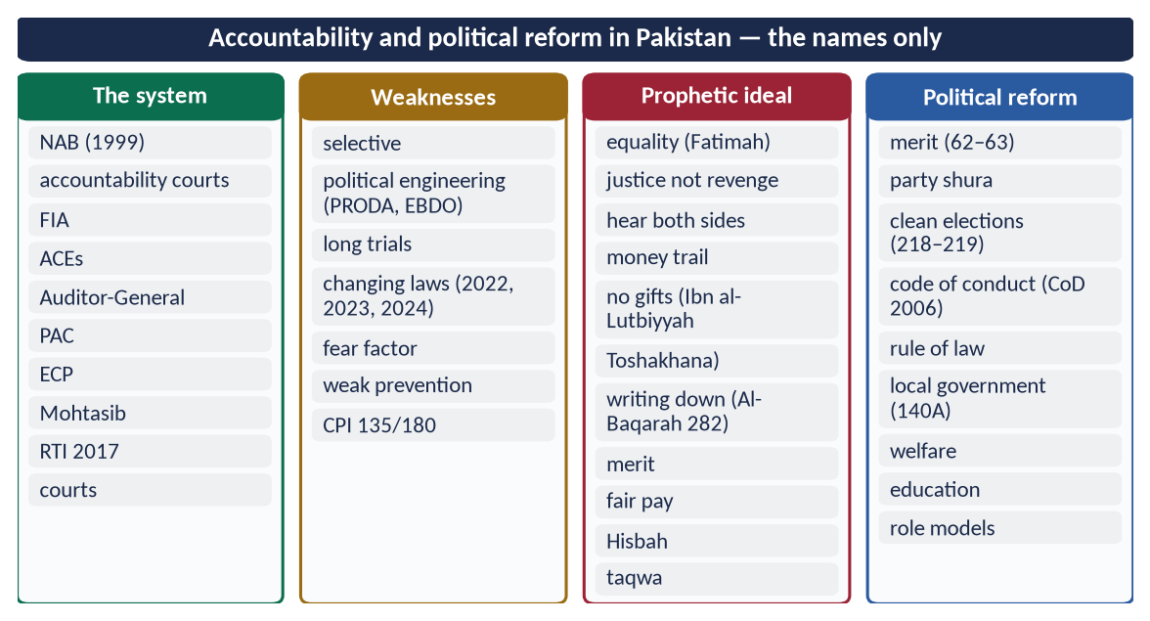
Figure 19 · At a glance — accountability and political reform in Pakistan — the names only. The detail is in the sections above.

Part Two — Contemporary Challenges, Narratives and Hot Debates

11.1 'Riyasat-e-Madinah' — a slogan or a model?
Several leaders in Pakistan have promised a state 'on the model of Madinah'. As a slogan it raises hopes without institutions. As a model it means concrete things:
- a written, supreme constitution (the Charter);
- rule of law for all (the Fatimah hadith);
- welfare for the weak (Zakat and stipends);
- rights for minorities (the Charter's clauses);
- consultation;
- honest, simple rulers;
- accountability that begins at the top.
The test of any claim is institutions and conduct, not words.
✦ QURAN
﴿يَـٰٓأَيُّهَا ٱلَّذِينَ ءَامَنُواْ لِمَ تَقُولُونَ مَا لَا تَفۡعَلُونَ ۝ كَبُرَ مَقۡتًا عِندَ ٱللَّهِ أَن تَقُولُواْ مَا لَا تَفۡعَلُونَ﴾
“O you who have believed, why do you say what you do not do. Great is hatred in the sight of Allah that you say what you do not do.” (As-Saf, Quran)
➜ O you who believe, why do you say what you do not do? Most hateful to Allah is that you say what you do not do.

11.2 The politicisation of the civil service
Transfers and postings made on political grounds, officers seen as belonging to one party or another, and the loss of security of tenure all break the Quaid's rule: 'servants of the people and the State'. Remedies:
- fixed tenures;
- transfers only by an independent board;
- promotion on performance;
- protection from illegal orders;
- the Islamic principle 'no obedience in disobedience'.

11.3 Corruption and public trust
Corruption raises the cost of every service and punishes the poor most. Pakistan's low place in the Corruption Perceptions Index (135/180 in 2024) reflects perception and public trust as much as cases. The Islamic answer joins:
- inner taqwa — the question 'where from, where to?';
- outer systems — audit, digital payments, open data;
- social pressure — Hisbah and a free press.

11.4 E-governance — the modern Diwan
Umar's Diwan was the technology of its age. Today's equivalents: NADRA's identity database; the Pakistan Citizen's Portal (2018); online tax filing; e-procurement (PPRA's e-PADS); digital land records in the provinces. E-governance reduces human contact, and so bribery, and speeds services. Its risks are data privacy (Al-Hujurat 12: 'do not spy') and exclusion of the poor who lack access.

11.5 Shura and parliament — is an elected assembly Islamic?
Most contemporary scholars, and Pakistan's Constitution, see an elected parliament as the modern form of Shura, working within Allah's limits (Article 2A, Article 227). Iqbal proposed that the power of Ijtihad pass to a Muslim legislative assembly, advised by scholars (Reconstruction, Lecture VI). The Council of Islamic Ideology links the two.

11.6 Women in public administration
- The Prophet ﷺ took Umm Salamah's (RA) advice at Hudaybiyyah.
- Umar (RA) is reported to have given al-Shifa' bint Abdullah (RA) duties in the market.
- The Hanafi school allows a woman to serve as a judge in matters other than hudud and qisas.
- Pakistan has women in every service group. Justice Ayesha Malik became the first woman judge of the Supreme Court in 2022.
The Islamic test for any officer, man or woman, is the same: 'strong and trustworthy'.

11.7 Governance and the economy
Ibn Khaldun warned that injustice ruins civilisation and that heavy taxes kill enterprise. Ali (RA) told Malik al-Ashtar to care for the land before the tax. Today this means a broad, fair tax base, an end to elite exemptions, spending on people (education, health), and a stable policy environment.
DEBATE · IS STRICT ACCOUNTABILITY BAD FOR GOVERNANCE?
Yes, some say: fear of cases makes officers avoid decisions, and files stop moving. The Islamic balance: accountability must be just — 'the burden of proof is on the claimant' — and must distinguish an honest mistake from corruption. The Prophet ﷺ said: 'If a ruler judges, strives and is right, he has two rewards; if he strives and errs, he has one reward' (Al-Bukhari and Muslim). Punish dishonesty, protect honest judgement.

Part Three — The Examiner's Record and Five Likely Questions

12.1 Every question on this topic, 2016–2026
Year | Question | Ch.
2016 Q6 | Highlight the concept of Public Administration in Islam. Explain the responsibilities of Civil Servants. | 1, 8
2016 Q7 | Discuss the salient features of Islamic political system in the light of governance under pious Khilafat-i-Rashida. | 3, 5
2017 Q4 | How were the Rightly-guided Caliphs elected? To what extent their system of government be regarded as democratic? | 5
2018 Q5 | Highlight the responsibilities of civil servants in the light of Islamic teachings. | 8
2019 Q8 | Give suggestions to reform Pakistani Politics keeping in view the different aspects of political system of Islam. | 10, 5
2020 Q3 | Write a comprehensive note on the bravery and juridical wisdom of Hazrat Ali (R.A). | 7
2021 Q6 | Express the principles of accountability of rulers according to the Holy Quran and Sunnah. | 9
2024 Q6 | How can the system of accountability in Pakistan be idealized in the teachings of the Holy Prophet (ﷺ)? Explain. | 10, 9
2026 Q6 | Explain the concept of accountability in the Islamic system. Demonstrate with examples that the practices of the Rashidun Caliphs in this perspective set the highest standard. | 9, 5, 6

All nine are answered in T8QA.

12.2 What the record teaches
- Accountability three times (2021, 2024, 2026): of rulers, in Pakistan, under the Rashidun. It is the favourite of recent papers.
- Civil servants twice (2016, 2018): a natural question for future officers.
- The Khilafat four times in different shapes: the political system (2016), election and democracy (2017), reforming Pakistani politics (2019), Hazrat Ali (2020).
- Never asked: the letters of Umar and Ali, Quranic guidance on good governance, Shura and legislation.

12.3 Five likely questions
1. Discuss the letters of Hazrat Umar (RA) and Hazrat Ali (RA) to their governors and judges, and their lessons for the civil servants of Pakistan.
2. What guidance does the Holy Quran give for good governance? Discuss.
3. Explain the institution of Shura and its place in the legislative structure of a modern Islamic state.
4. Hazrat Umar (RA) was the greatest administrator of Islam. Discuss.
5. Explain the institution of Hisbah and suggest how it can be revived in Pakistan.

Part Four — The One-Liner Bank

One-liners · Public administration and Quranic guidance
1. Administration in Arabic: idarah; governance by the Shari'ah: siyasah shar'iyyah.
2. 'I am placing on the earth a khalifah' — Al-Baqarah 30.
3. The Quran's 'job description' of a Muslim government: Al-Hajj 41 (prayer, Zakat, enjoining good, forbidding evil).
4. 'Render trusts to those entitled, and judge with justice' — An-Nisa 58.
5. Obey Allah, the Messenger and those in authority; refer disputes to Allah and the Messenger — An-Nisa 59.
6. 'The best one you can hire is the strong and the trustworthy' — Al-Qasas 26.
7. Yusuf: 'I am a knowing guardian (hafiz 'alim)' — Yusuf 55.
8. The verse against ghulul (embezzlement) — Aal-e-Imran 161.
9. Wealth must not circulate only among the rich — Al-Hashr 7.
10. 'We will surely question them all' — Al-Hijr 92–93.
11. Pharaoh divided the people into groups — Al-Qasas 4.
12. 'O Abu Dharr, you are weak, and it is a trust' — Muslim.
13. 'When authority is given to those not fit for it, wait for the Hour' — Al-Bukhari.
14. 'Whoever shuts himself away from their needs, Allah shuts Himself away from his' — Abu Dawud.
15. Mu'adh's order of judging: Quran → Sunnah → his own Ijtihad.
16. The Prophet's ﷺ secretary for letters and revelation: Zayd ibn Thabit (RA).
17. The Prophet's ﷺ governor of Makkah after the conquest: 'Attab ibn Asid (RA).
18. The Zakat collector who kept 'gifts': Ibn al-Lutbiyyah.

One-liners · Governance in the Sunnah and Fiqh
19. 'If Fatimah the daughter of Muhammad stole, I would cut off her hand' — Al-Bukhari and Muslim.
20. 'I never saw anyone consult his companions more than the Messenger ﷺ' — Abu Hurayrah (Al-Tirmidhi).
21. 'The best of your rulers are those whom you love and who love you' — Muslim.
22. First of the seven under Allah's shade: the just ruler.
23. A ruler who dies deceiving his people — Paradise is forbidden to him (Muslim).
24. Kitab al-Kharaj was written by Imam Abu Yusuf for Harun al-Rashid.
25. Al-Siyar (international law): Imam Muhammad al-Shaybani.
26. Al-Ahkam al-Sultaniyyah: al-Mawardi (d. 1058).
27. Al-Mawardi lists ten duties of the ruler.
28. 'Injustice ruins civilisation': Ibn Khaldun, Al-Muqaddimah.

One-liners · Shura and legislation
29. 'Their affairs are by consultation among themselves' — Ash-Shura 38.
30. In Ash-Shura 38, consultation stands between prayer and Zakat.
31. 'Consult them in the matter' was revealed after Uhud — Aal-e-Imran 159.
32. 'The one who is consulted is in a position of trust' — Abu Dawud and Al-Tirmidhi.
33. The Companion who suggested a better site at Badr: Hubab ibn al-Mundhir.
34. At Uhud the Prophet ﷺ followed the majority against his own view.
35. The trench was proposed by Salman al-Farsi (RA).
36. The advice that solved the crisis at Hudaybiyyah: Umm Salamah (RA).
37. Umar kept the lands of Iraq as state land after long Shura.
38. 'The judgement belongs only to Allah' — Yusuf 40.
39. Iqbal proposed that Ijtihad pass to a Muslim legislative assembly — Lecture VI.
40. Objectives Resolution: 1949; made substantive as Article 2A in 1985.
41. No law repugnant to Islam: Article 227.
42. The Federal Shariat Court: Article 203 (1980).

One-liners · The Khilafat-e-Rashidah
43. The Khilafat-e-Rashidah: 11–40 AH / 632–661.
44. 'The Khilafah will be for thirty years, then kingship' — narrated by Safinah (RA).
45. 'Hold to my Sunnah and the Sunnah of the Rightly-Guided Caliphs' — Abu Dawud, Al-Tirmidhi.
46. Abu Bakr was chosen at Saqifah Bani Sa'idah.
47. The first to pledge to Abu Bakr at Saqifah: Umar (RA).
48. 'I am not the best of you … if I do wrong, set me right' — Abu Bakr's first address.
49. Umar was nominated by Abu Bakr after consulting senior Companions.
50. The council of six: Uthman, Ali, Talhah, Zubayr, Sa'd, Abd al-Rahman ibn Awf.
51. Umar barred his son Abdullah from the Caliphate.
52. The man who polled the people for three days: Abd al-Rahman ibn Awf (RA).
53. Abu Bakr's stipend was returned from his property at his death: 'He made it hard for those after him' (Umar).
54. The Quran was compiled under Abu Bakr (12 AH) and standardised under Uthman.
55. The first Muslim navy took Cyprus in 649 (28 AH).
56. Iqbal: the republican form of government is 'thoroughly consistent with the spirit of Islam'.
57. Called the 'fifth Rightly-Guided Caliph': Umar ibn Abd al-Aziz (717–720).

One-liners · Hazrat Umar (RA)
58. Umar's title: al-Faruq; his rule: 634–644 (13–23 AH).
59. 'If there were a prophet after me, it would be Umar' — Al-Tirmidhi.
60. The register of stipends: the Diwan (about 20 AH).
61. The Hijri calendar was fixed in 17 AH / 638.
62. The first prison in Islam: a house bought in Makkah by Umar.
63. Garrison cities founded under Umar: Basra, Kufa, Fustat.
64. The famine year: 'Am al-Ramadah, 18 AH.
65. Umar's judge in Kufa: Qadi Shurayh.
66. Umar's letter on judging was sent to Abu Musa al-Ash'ari (RA).
67. 'The burden of proof is on the claimant; the oath on the one who denies.'
68. 'Do not let yesterday's judgement stop you from returning to the truth' — Umar's letter.
69. Umar's inspector of governors: Muhammad ibn Maslamah (RA).
70. Sharing unexplained wealth of governors with the treasury: muqasamah.
71. 'Since when have you enslaved people whose mothers bore them free?' — Umar to Amr ibn al-As.
72. Umar's sons' trade on a treasury loan became a partnership — Al-Muwatta'.
73. 'Take account of yourselves before you are taken to account' — Umar.

One-liners · Hazrat Ali (RA)
74. Ali slept in the Prophet's ﷺ bed on the night of the Hijrah.
75. At Khandaq Ali killed 'Amr ibn 'Abd Wudd.
76. 'I will give the flag tomorrow to a man who loves Allah and His Messenger' — Khaybar.
77. 'You are to me as Harun was to Musa' — said at Tabuk.
78. 'The best judge among us is Ali' — Umar (Al-Bukhari).
79. The Prophet ﷺ sent Ali to Yemen as a judge.
80. 'Do not judge for the first until you hear the other' — to Ali (Al-Tirmidhi).
81. Minimum pregnancy of six months: Al-Ahqaf 15 + Luqman 14.
82. 'The pen is lifted from three' — the insane woman's case.
83. Ali lost the armour case before Qadi Shurayh.
84. Ali's letter of governance was to Malik al-Ashtar, governor of Egypt (38 AH / 658).
85. The letter is preserved in Nahj al-Balaghah (Letter 53).
86. 'Your brother in religion or your equal in creation.'
87. Ali told his governor to care for the land before the tax.

One-liners · Civil servants
88. A civil servant in Islam is a trustee (amin), not a ruler.
89. Hiding even a needle of public property is ghulul — Muslim.
90. The briber and the bribe-taker are cursed — Abu Dawud, Al-Tirmidhi.
91. 'We do not appoint anyone who asks for it' — Al-Bukhari and Muslim.
92. 'Allah loves that when you do a job, you do it with perfection (itqan)' — Al-Bayhaqi.
93. 'No obedience in disobedience; obedience is only in what is right.'
94. Quaid to officers: 'servants of the people and the State, fearlessly and honestly' — Peshawar, 14 April 1948.
95. Quaid: 'You do not belong to the ruling class' — Chittagong, 25 March 1948.

One-liners · Accountability and Hisbah
96. The Day of Judgement is the Day of Reckoning (Yawm al-Hisab).
97. 'Whoever does an atom's weight of evil will see it' — Az-Zalzalah 8.
98. Asked about wealth: 'where he earned it and how he spent it' — Al-Tirmidhi.
99. The Companion who asked the Prophet ﷺ for retaliation at Badr: Sawad ibn Ghaziyyah.
100. 'The best jihad is a word of justice before a tyrant ruler' — Abu Dawud, Al-Tirmidhi.
101. 'Religion is sincere advice … to the leaders of the Muslims' — Muslim.
102. Hisbah rests on Aal-e-Imran 104 and At-Tawbah 71.
103. 'Whoever cheats is not of me' — said at the heap of grain (Muslim).
104. The officer of Hisbah: the muhtasib.
105. The court of grievances against officials: Diwan al-Mazalim.
106. Wafaqi Mohtasib (Federal Ombudsman): 1983.
107. Federal Tax Ombudsman: 2000; harassment Ombudsperson law: 2010.
108. Pakistan Citizen's Portal: 2018.

One-liners · Accountability in Pakistan
109. PRODA: 1949; EBDO: 1959.
110. Ehtesab Act: 1997; National Accountability Ordinance and NAB: 1999.
111. Right of Access to Information Act: 2017.
112. NAB amendments narrowed jurisdiction: 2022; upheld by the Supreme Court: 2024.
113. Auditor-General of Pakistan: Articles 168–171.
114. Election Commission: Articles 218–219.
115. Qualifications of members of Parliament: Articles 62–63.
116. Transparency International CPI 2024: Pakistan 135th of 180.
117. The Quran's longest verse is about writing down transactions — Al-Baqarah 282.
ONE-LINER COUNT
This topic carries 117 one-liners, numbered 1–117. Revise them in blocks of twenty; tick the ones you can answer without looking.

Part Five — Revision Notes · Topic 8
Read these on the night before the paper. Every chapter is broken into its sections, each giving the chain of ideas, the evidence to quote, and the names, dates and numbers. The last line of each chapter tells you which question it serves.

R8.0 The whole topic in one picture
- The frame: sovereignty of Allah → authority as a trust (khilafah) → justice as the aim → Shura as the method → accountability as the check.
- The model: the Prophet ﷺ in Madinah (Charter, governors, market inspection) → the Rashidun (election, Shura, courts, simplicity) → Umar's administration → Ali's letter.
- The people of the system: the ruler, the civil servant, the judge, the muhtasib — all trustees.
- Pakistan: 2A and 227 give the frame; NAB, the Mohtasib and the Auditor-General give the tools; merit, fairness and taqwa are missing.

R8.1 Chapter 1 · Public administration (2016)

1.1–1.2 Meaning and aims
- idarah + siyasah shar'iyyah → running public affairs as amanah → khalifah (Al-Baqarah 30).
- Aims: Al-Hajj 41 · justice (Al-Hadid 25) · five essentials · welfare · security (Quraysh 3–4) · enjoining good · development.

1.3 Ten principles (draw the pillars)
- Tawhid (Yusuf 40) · amanah (An-Nisa 58; Abu Dharr) · 'adl (An-Nahl 90) · shura (Ash-Shura 38) · merit (Al-Qasas 26; 'wait for the Hour') · accountability (shepherd) · access (Abu Dawud) · ihsan (Muslim) · simplicity (Umar) · welfare for all (the Jewish beggar).

1.4 The Prophet's ﷺ administration
- Charter 622 · Mu'adh to Yemen; 'Attab to Makkah · Zayd ibn Thabit · Zakat collectors (Ibn al-Lutbiyyah) · the grain heap · envoys · census · Mu'adh: Quran → Sunnah → Ijtihad.

1.5 Modern vs Islamic
- Same tools (merit, audit, records), plus taqwa and the Hereafter.
- Exam use: 2016 first limb → meaning → aims → principles → Prophet's model → comparison.

R8.2 Chapter 2 · Quranic guidance on good governance (likely)
- Twelve principles:
- trusts and justice (An-Nisa 58);
- conditional obedience and referral to law (An-Nisa 59);
- justice against self (An-Nisa 135) and to enemies (Al-Ma'idah 8);
- shura (Aal-e-Imran 159);
- merit (Al-Qasas 26; Yusuf 55);
- no ghulul (Aal-e-Imran 161) and no bribes (Al-Baqarah 188);
- wealth for all (Al-Hashr 7);
- verify (Al-Hujurat 6);
- contracts (Al-Ma'idah 1; Al-Isra 34);
- questioning (Al-Hijr 92–93; As-Saffat 24);
- no superiority (Al-Qasas 83);
- Pharaoh as the anti-model (Al-Qasas 4).
- Models: Yusuf (planning in famine) · Dawud (Sad 26) · Sulayman · Dhul-Qarnayn (refused payment) · Bilqis's council.
- Table: the UN's eight marks ↔ Quranic verses.
- Exam use: 'Quranic guidance on good governance' → define good governance → twelve principles with verses → models → table.

R8.3 Chapter 3 · Governance in the Quran, Sunnah, Fiqh
- Three relationships: Allah–ruler (trust) · ruler–people (bay'ah contract) · ruler–law (under it).
- Quran: An-Nur 55 · Aal-e-Imran 26 · Sad 26 · An-Nisa 59 → five foundations.
- Sunnah: 'Aqabah → Charter · Fatimah hadith · 'most consultative' · mercy du'a · deceiving ruler denied Paradise · 'rulers you love' · just ruler first of seven.
- Fiqh: Abu Yusuf (Kharaj) · Shaybani (Siyar) · al-Mawardi (Ahkam; ten duties) · Ghazali · Ibn Khaldun · maxim: ruler's acts bound by welfare.
- Exam use: background for 2016 Q7 and 2019.

R8.4 Chapter 4 · Shura and legislation
- Shura: honey · Ash-Shura 38 (between prayer and Zakat) · Aal-e-Imran 159 (after Uhud) · 'the adviser is trusted'.
- Practice: Badr (Hubab) · prisoners · Uhud (majority) · Khandaq (Salman) · Hudaybiyyah (Umm Salamah) · Umar's majlis · Iraq lands · 'no Khilafah without consultation'.
- Binding or advisory: both views → today, parliament binds within the Constitution.
- Legislation: Allah the Lawgiver (Yusuf 40; Al-Ma'idah 44) → human law: apply, Ijtihad, mubah by maslahah, Iqbal's assembly.
- Pakistan: 1949 · 2A · 2 · 227 · CII 228–231 · FSC 203 · 31.
- Separation of powers: judges separate from governors (Shurayh); Umar before Zayd; Ali before Shurayh.
- Exam use: likely question on Shura; supports 2016 Q7 and 2019.

R8.5 Chapter 5 · The Khilafat-e-Rashidah (2016 Q7, 2017)

5.1–5.2 The period and the election (draw the four ways)
- 632–661 · 'thirty years' (Safinah) · 'my Sunnah and the Rashidun' (Abu Dawud).
- Abu Bakr: Saqifah → Umar's pledge → special → general bay'ah → 'set me right'.
- Umar: nomination after consulting Abd al-Rahman, Uthman → written → bay'ah.
- Uthman: council of six → Abd al-Rahman polls the people for three days → bay'ah.
- Ali: crisis → public bay'ah in the Mosque.
- Common principles: no heredity · consultation · consent · merit · no self-seeking.

5.3 Fourteen features
- sovereignty · trust ('guardian of an orphan') · consent · shura · equality · independent courts · accountability · free speech ('no good in you if you do not say it') · rights · minorities (Jerusalem 638) · welfare · treasury as trust · simplicity · merit.

5.4 Each Caliph
- Abu Bakr: Riddah · Usamah · Quran compiled · stipend returned.
- Umar: administration.
- Uthman: standard Quran · navy (Cyprus 649) · public answers · inspectors.
- Ali: equal shares · judgements · letters.

5.5 Democratic?
- Similar: consent, shura, law, accountability, speech, equality, minorities, no heredity.
- Different: Allah sovereign · qualifications · flexible method · no fixed term.
- Verdict: democratic in spirit; consultative, accountable, law-bound (Iqbal, Lecture VI).

5.6 After 661
- Heredity → the ideal remained the standard → Umar ibn Abd al-Aziz.
- Exam use: 2017 → the four elections + principles → table of similarities → differences → verdict. 2016 Q7 → features table with Rashidun examples.

R8.6 Chapter 6 · Hazrat Umar (RA) and his letters (likely)
- Administration (draw the structure): eight provinces · wali, katib, kharaj, ahdath, bayt al-mal, qadi · Diwan (c. 20 AH) · prison · Hijri calendar 17 AH · Basra, Kufa, Fustat · canal · land survey · kharaj · jizyah exemptions.
- Welfare: stipends from birth · the Jewish beggar (Kitab al-Kharaj) · night rounds · Ramadah 18 AH (no meat, relief, theft penalty suspended).
- Letter to Abu Musa (Daraqutni; Bayhaqi; Ibn al-Qayyim): understand · equality in look, seat, justice · proof and oath · settlement · time for evidence · review · qiyas · witnesses · temperament · sincerity.
- Governors:
- written conditions (no fine horse, clothes, bread, doorkeeper);
- 'not tyrants but leaders of guidance';
- Sa'd: fear sins more than the enemy;
- the Copt: 'since when have you enslaved …'.
- Checks:
- asset register and muqasamah (Abu Hurayrah, Amr);
- Muhammad ibn Maslamah;
- Hajj hearings;
- Sa'd removed; Khalid removed;
- sons' partnership (Muwatta').
- Exam use: 'letters of Umar and Ali' → Umar's two letters (judging; governors) + Ali's letter → lessons for Pakistan's civil servants.

R8.7 Chapter 7 · Hazrat Ali (RA) (2020)
- Life: first boy to believe · cousin, son-in-law · Caliph 656–661 · martyred Ramadan 40 AH.
- Bravery: Hijrah night · Badr (al-Walid) · Uhud · Khandaq ('Amr ibn 'Abd Wudd) · Khaybar (the flag; al-Qamus) · Hunayn · Tabuk ('as Harun to Musa') · restraint in anger.
- Juridical wisdom:
- Yemen ('guide his heart'; 'hear the other');
- 'the best judge among us' (Umar, Al-Bukhari);
- six months (Al-Ahqaf 15 + Luqman 14);
- the pen lifted (insane woman);
- three men and the lots;
- the armour before Shurayh;
- equal shares ('Aqil);
- the Hijri calendar;
- grammar (Abu al-Aswad).
- Letter to Malik al-Ashtar (38 AH; Nahj al-Balaghah 53):
- mercy;
- 'brother or equal';
- common people before the elite;
- humility;
- advisers;
- seven classes;
- judges well paid;
- officials by test and inspected;
- land before tax;
- no hoarding;
- the poor;
- access;
- treaties;
- no bloodshed.
- Exam use: 2020 → life → bravery (battles in order) → juridical wisdom (testimony + cases table) → administration (letter) → conclusion.

R8.8 Chapter 8 · Civil servants (2016, 2018)
- Qualities (draw the five): qawiyy · amin (Al-Qasas 26) · hafiz · 'alim (Yusuf 55) · 'adil (An-Nisa 58).
- Thirteen duties:
- trust (Al-Anfal 27; the hypocrite's signs);
- no ghulul (the needle);
- no bribes or gifts (Ibn al-Lutbiyyah);
- merit ('we do not appoint one who asks');
- justice to all;
- access;
- gentleness;
- itqan (the ajir khass);
- lawful obedience only;
- records and secrets;
- no conflict of interest;
- neutrality;
- accountability.
- Quaid: Peshawar, 14 April 1948 (no pressure; fearlessly and honestly) · Chittagong, 25 March 1948 (servants, not rulers).
- Law: Civil Servants Act 1973 · Conduct Rules 1964 · E&D 2020 · Articles 5, 240–242.
- Problems ↔ cures table.
- Exam use: 2018 → definition → Quranic qualities → duties with hadith → Quaid → Pakistan's problems and cures.

R8.9 Chapter 9 · Accountability and Hisbah (2021, 2026)
- Concept: Yawm al-Hisab · Az-Zalzalah 7–8 · Al-Isra 36 · At-Takathur 8.
- Levels (draw the circles):
- Allah (Al-Hijr 92–93; 'where earned, how spent');
- self (Umar);
- law (Fatimah; Sawad at Badr; Caliphs in court);
- people ('set me right'; word of justice; nasihah);
- institutions.
- Ten principles (2021): trust · under law · conditional obedience · right to correct · wealth transparency · no private gain · equality · shura · independent judges · lawful removal.
- Hisbah:
- basis: Aal-e-Imran 104 · At-Tawbah 71 · 'change it with the hand';
- history: the grain heap · Makkah market officer · Umar in the market · al-Shifa' · the muhtasib · al-Mawardi;
- duties: market, health, order, morals, professions, officials;
- limit: no spying (Al-Hujurat 12).
- Mazalim: complaints against officials → Abd al-Malik → Umar ibn Abd al-Aziz → ombudsman.
- Today: Mohtasib 1983 · Tax 2000 · harassment 2010 · Citizen's Portal 2018.
- The Rashidun standard (2026):
- Abu Bakr — stipend returned;
- Umar — assets, muqasamah, inspector, Hajj, sons;
- Uthman — public answers, inspectors;
- Ali — Shurayh, 'Aqil;
- why the highest: it began at the top, rested on taqwa, and was public.
- Exam use: 2021 → concept → principles table with evidence. 2026 → concept + levels → the four Caliphs' examples → why the highest standard.

R8.10 Chapter 10 · Pakistan (2019, 2024)
- System: NAB 1999 · courts · FIA · ACEs · AGP 168–171 · PAC · ECP 218–219 · Mohtasib · RTI 2017 · superior courts.
- Weaknesses:
- selective;
- political engineering (PRODA 1949, EBDO 1959);
- long trials;
- changing laws (2022 → 2023 → 2024);
- the fear factor;
- some institutions above the law;
- weak prevention;
- CPI 135/180.
- Ten Prophetic ideals (2024): equality (Fatimah) · justice, not revenge (Al-Ma'idah 8) · due process ('hear the other'; 10-A) · money trail (Al-Tirmidhi; asset declarations) · no gifts (Ibn al-Lutbiyyah) · writing down (Al-Baqarah 282; e-governance) · merit · fair pay · Hisbah (whistle-blowers, press) · taqwa (Al-Hadid 4).
- Politics (2019):
- problems table: dynasties, money, floor-crossing, no party shura, hate speech, chaos, corruption, imbalance, no local government;
- ten suggestions: 62–63 fairly · party elections · clean elections · fair accountability · code of conduct (CoD 2006) · rule of law · 140A · welfare politics · political education · role models;
- end with Ar-Ra'd 11.
- Exam use: 2024 → system → weaknesses → ten Prophetic ideals, each with a reform. 2019 → Islamic political system in brief → problems table → suggestions.

R8.11 Part Two · Today
- Riyasat-e-Madinah: slogan vs model → seven institutions → As-Saff 2–3.
- Politicisation: tenure, boards, performance, lawful obedience.
- Corruption and trust: CPI → taqwa + systems + Hisbah.
- E-governance: Umar's Diwan → NADRA, Citizen's Portal, e-PADS; privacy (Al-Hujurat 12).
- Parliament as Shura: 2A, 227, CII, Iqbal.
- Women in administration: Umm Salamah · al-Shifa' · the Hanafi judge rule · Justice Ayesha Malik (2022).
- Economy: Ibn Khaldun · land before tax.
- Debate: strict accountability vs decision paralysis → punish dishonesty, protect honest judgement ('two rewards, one reward').

R8.12 The figures to draw in the paper
- The pillars of good governance: Tawhid at the base; amanah, 'adl, shura, merit, accountability, ihsan.
- The four elections of the Caliphs: four rows, one principle.
- Umar's structure: Caliph – Shura – inspection; provinces; six officers.
- Ali's circle of society: the governor in the centre, seven classes around.
- The circles of accountability: self → people → law → Allah.
- The five qualities of the civil servant: qawiyy, amin, hafiz, 'alim, 'adil.
- The Hisbah timeline: Madinah → Mohtasib 1983.

